Part 3: Creating Fenders and Lights
13) Use the offset tool to create another curved edge around the wheel well opening. Make sure to start on the edge of the circle and then pull about 2mm away from the edge.
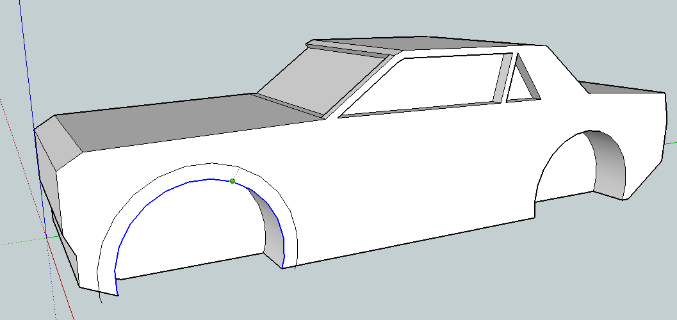
14) Use the push/pull tool 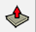 to push out the fender to at least 1.5mm-2.0mm. 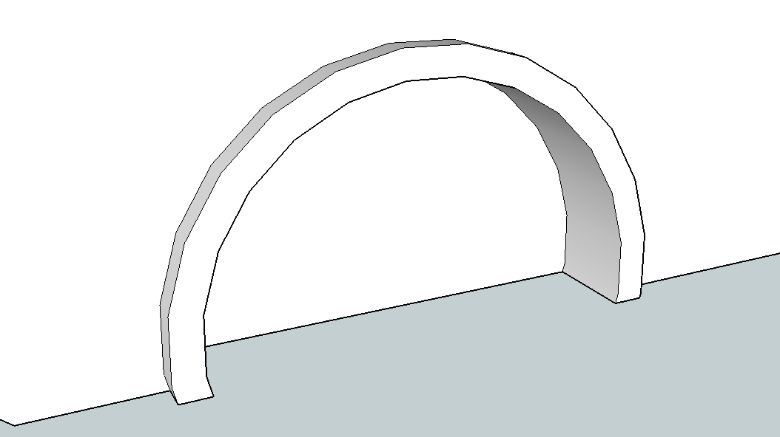
Make sure to use the to erase the two extra lines sticking out below the base of the car.
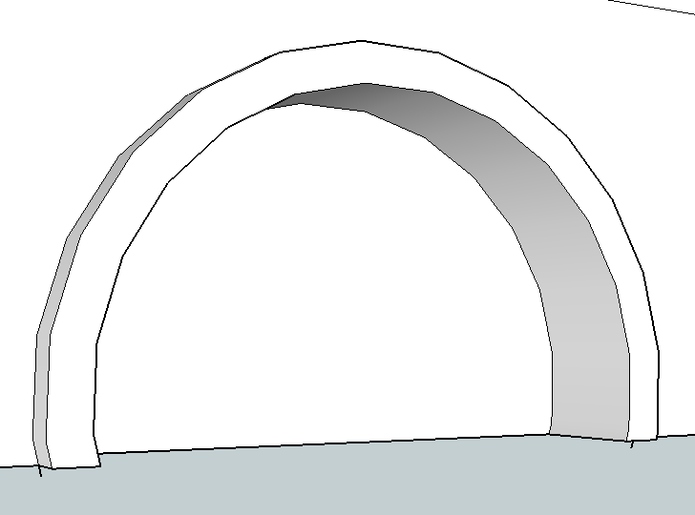

NEXT: Repeat for the back wheel! NOTE: ONLY DO ONE SIDE OF THE CAR!!!
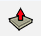
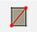
Adding Headlights and Taillights:
15) Use the circle tool or rectangle tool to add a headlight to the front of the car. Remember we are only doing ONE SIDE of the car right now so you just need ONE light.
16) Then push/pull the light to give it dimension (1-2mm). Decide if you like it extending out of the car, or pushed into the car. Pushed in will likely print a little better, but either way can work.
17) Draw a line to make a rectangle on the back of the car then use the offset tool to make a smaller rectangle inside. Add some more lines if you want more more than one light.
18) Erase the extra lines and the use the push/pull tool to make the lights 3D.
Add at least 2 other Details to your car LIKE:
A Grill, Hood Scoop, Bumper, Spoiler, License Plate Indention, Exhaust Pipes, …
Make sure you are completely happy with your car before you move on to the next step.

