Part 4: Putting it all together
20) Select the entire car. Copy [ctrl-C] and Paste [ctrl-V].
21) Paste the copy next to the first half.

22) RIGHT CLICK on the car and select “FLIP ALONG” and then choose “RED DIRECTION”
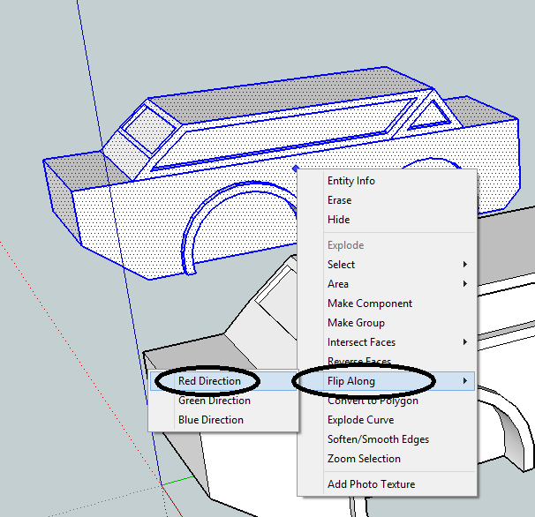

The car will have now flipped sides
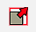
23) Now use the move tool to put the two pieces together. Make sure to select a corner and move it to line up with the same spot on the other side. You may need to zoom in closely first.
24) You may want to adjust the scale of the entire car. Drag a box around the whole car.
25) Then use the scale tool to adjust the width of the car (RED scale).
DON’T CHANGE the BLUE or GREEN scales or your wheel wells won’t be round anymore.
MAKE SURE there are still at least 43mm between the wheel wells on the bottom.
26) Check your car closely for any design flaws. Look for any missing sections, extra lines sticking out, or any pieces that are slightly blue. If you find a blue piece right click on it and select “reverse faces”. Blue pieces are inside out and may cause your print to fail.

