Name: _______________

Period: _______________

5 Essential Questions:
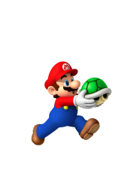
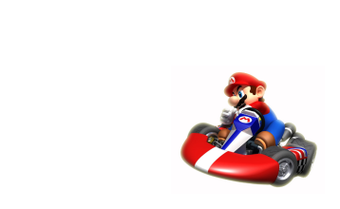
- What type of game will you make? (circle one)

Exploring/Story Racing
The characters are free to move around The characters must follow a
on their own and must complete a task specific path in a certain time

- Who will be the main character? (circle one)

- Kodu: slow but can jump
- Rover: can jump and use drill/laser
- Cycle: fast and can jump high
- Jetty: fast and can fly up and down
- Octo: can swim and go up and down
- Saucer: very fast can fly up and down
- Turtle: can move and hide in its shell
- Other: _________________________

- What will be the objective?
What should your characters do? What is their goal in the game?
Examples: Collect coins, kill enemies, complete a race . . .
____________________________________________________________________________________________________________________________________

- What will be the challenges?
What will make the game difficult and entertaining?
Examples: Bad guys, obstacles, time limit . . . ____________________________________________________________________________________________________________________________________
- What will the world look like?
What will the world/level look like? Describe the look and feel of your world with words first, and then sketch a picture of your world in the space below.
Examples: Forest, City, Island, Racetrack . . . made of: Trees, bricks, grass, colors…
____________________________________________________________________________________________________________________________________

6 Elements of a Good Game:
- Good environment/setting
- Clear directions/goals for the character
- Interesting story line
- Music and sound effects
- Talking creatures/objects
- Hidden secretes!

