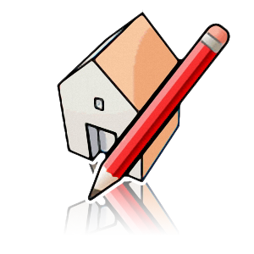
Google SketchUp Design Project: Grades 6 - 8

To get our creative juices flowing we will start using Sketch Up to create and design our own house. This project will allow you to get familiar with the program by creating by using basic tools that will quickly help you design a fun, colorful house with windows and doors, and other creative features. Once you get familiar with the program we will then start designing our 3D Cars!!!

VERY IMPORTANT: Read all directions carefully!!! Do not skip steps! If you do not READ every step your house will have a lot of problems with your design and may have to start over from the beginning. Please always remember to SAVE your project before you leave for the day!

- Start with a Rectangle , and Push/Pull 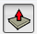 it up to a box.
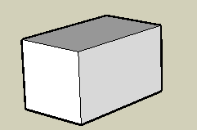

- To make the roof, use the Line tool and draw a line on the roof between midpoints. Then click on the MIDPOINT in the center of the line.
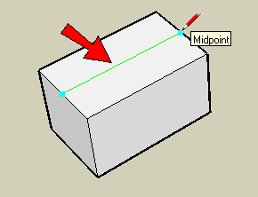

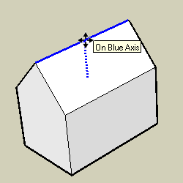

- Add a rectangle on the front face, to make a door.
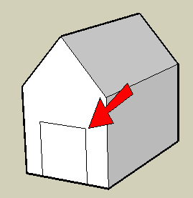
- To make a more interesting door, add an arc at the top (use the Arc tool).
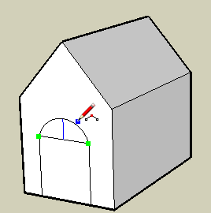

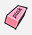
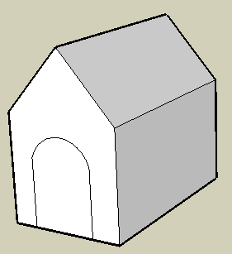

7. To remove the door face, right-click on it and choose Erase.
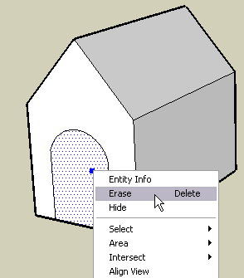
Now you can see into the house.
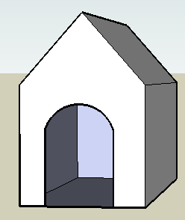

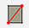
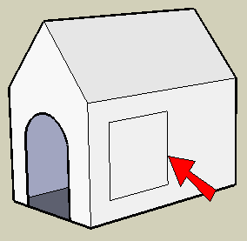

- Of course, windows don't have to be rectangles! Use Line and make some strange shape for a window. Be sure that you see “On Face” while making lines, or the lines might end up sticking out of the house.
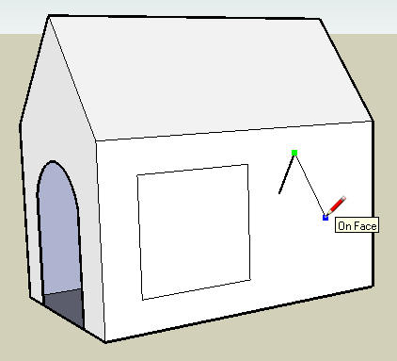
- Be sure to end the window shape where you started. If your lines are correct, the edges around the window will be thin.
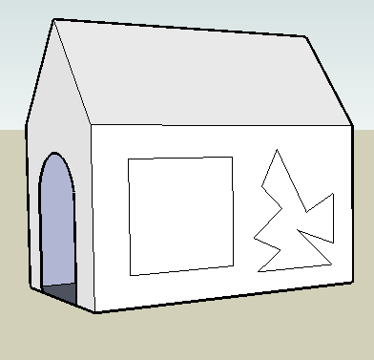

- Now we can color our house, starting with the roof. Click the Paint Bucket tool to open the Materials window (Colors on the Mac). Open the “Roofing” folder and click one of the swatches (I'm using the red metal roof, but you can choose your own).
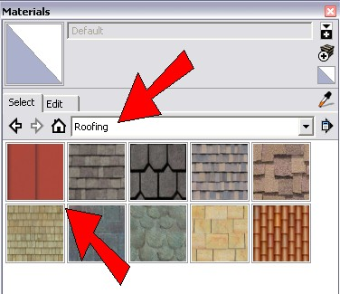
- Then click the roof face (don't forget to paint both sides of the roof). Use Orbit to navigate.
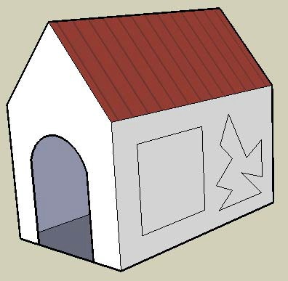
- For the walls, I'm using tan bricks from the “Bricks and Cladding” folder. Choose your own color.

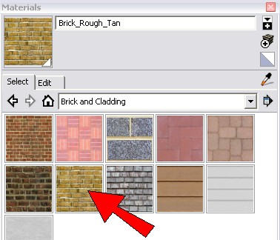

Here are the painted sides of the house:
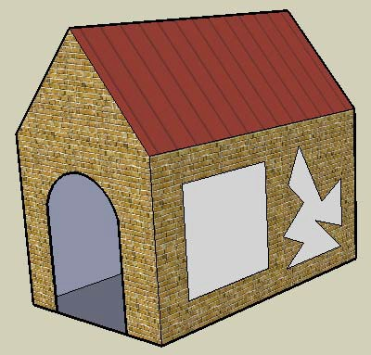
- Color your windows using colors in the “Translucent” folder.
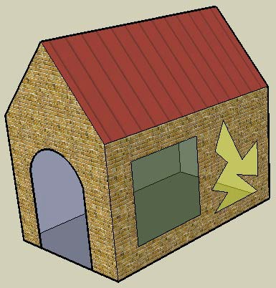
- These windows are so plain - let’s make them more interesting. Add some vertical stripes to this window by using the Line tool.
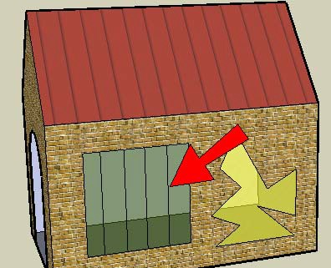

- Then paint the stripes using different translucent colors.
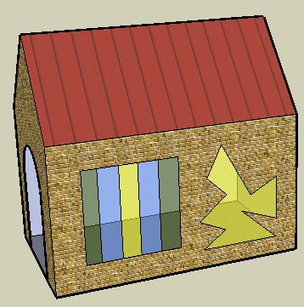
- Let’s design your door. Just use Line to redraw and connect the left side to the right side and the door face comes back. Use the Eraser to get rid of the line.

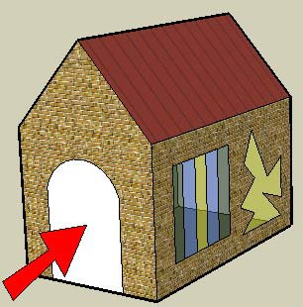

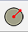
- To dress up the door, you can add a Circle for a window. Paint the door and the circle. I painted my door with cherry wood from the “Wood” folder. I painted the Circle with the “translucent colors.”
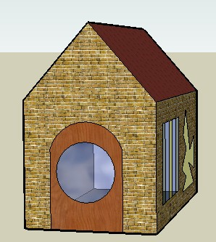

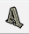
- To personalize the house, you can add text using the 3D Text tool

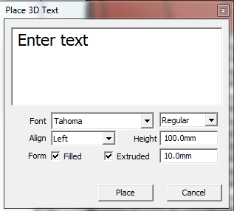

Change your Height to 100.00
Change Extruded to 10.00

3D Text requires that you enter a specific font and size, so you might have to try a few times to get the exact text you want. It also comes into the model as a component, so if you want to change it, you need to edit the component first (or explode the component).
