11/19/2014

|  |
| --- |
|  |





**2015 Middle School**

**Tournament of Technology**

Coaches Handbook

*Table of Contents*

TOURNAMENT OVERVIEW 3

SCORING AND TEAM ENTRIES 3

TOURNAMENT TIMELINE 3

MAIN EVENTS OVERVIEW 4

LIVE CHALLENGES AND DESIGN DOCUMENTS 5

COACHES’ ROLES AND RESPONSIBILITES 5

EVENT DESCRIPTIONS 6

3D Design - *3D Derby*  7-10

3D Design – *Bridge Building* 11-13

Video Game Design - *Kodu* 14-16

Graphic Design - *Infographic* 17-19

Lego Robotics - *Battle Bots* 20-23

Lego Robotics - *Block Bots* 24-27

Lego Robotics - *Line Follower* 28-31

Lego Robotics – *Robo Rally* 32-35

Video Production - *Advertisement* 36-38

Video Production - *Public Service Announcement* 39-41

Video Production - *Newscast* 42-45

Video Production - *Blockbuster* 46-49

COPYRIGHT REQUIREMENTS 50

COPYRIGHT GUIDELINES 51

INTERNET SAFETY FORMS 52

SAMPLE PARENT LETTER 53

CONTACT INFORMATION 54

**TOURNAMENT OVERVIEW**

On ***Saturday March 21st, 2015*** students, coaches and parents will come together at ***Gaston Middle School*** to participate in the eighth annual Tournament of Technology. Students will compete in 12 inspiring events designed to encourage students to work together as they apply their technology interests and skills in engaging and challenging ways.

During the day of competition, there will be onsite events and student presentations of previously created projects, live robotics competitions, technology displays and a variety of other venues in which to participate.

The Tournament Mission is to:

* Engage students with a variety of innovative technologies to help develop the 4 C’s of 21st Century learning: Collaboration, Communication, Critical Thinking and Creativity.
* Prepare teachers and students for the implementation of the Common Core Standards.
* Help teachers throughout the district infuse technology into their classrooms to enhance the learning environment of our students.

**SCORING AND DIVISIONS**

Each school may enter up to 5 teams into each event. All teams will be considered for individual awards for each event, however, **only the best three teams** from each school will be counted for the overall team sweepstakes.

The first place team in each event will be awarded 10pts for their school, 2nd= 8pts, 3rd=6pts, 4th= 4pts, 5th=2pts, and 6th place will earn 1 point. Again, only the top 3 teams from each school will be considered for overall team scores and the other teams from that school will be removed from the rankings. Points from each event will be added together for overall team scores.

There will be **two divisions** to make the tournament more equitable for schools participating with fewer teams. The 5 schools with the most registered teams will be entered into Division 1 and the remaining schools will be in Division 2. A school may opt to bump up to Division 1 if they choose. Awards and trophies will be passed out for each division.   
  
Additionally the tournament will be split into **3 categories**: Robotics, Video, and Design. There will be team trophies awarded for each category, as well as the overall tournament.

**TOURNAMENT TIMELINE**

|  |  |  |
| --- | --- | --- |
| **Date** | **Event** | **Location** |
| November 17, 2014 | Initial Coaches Meeting | Gaston Library |
| December 1, 2014 | Registration Opens | TOT Website |
| **March 6, 2015** | **Registration Closes** | **TOT Website** |
| **March 6, 2015** | **Project Submission Deadline** | **TOT Website** |
| March 16, 2015 | Final Coaches meeting | Gaston Library |
| March 12 and 19 | Judges Orientation | Gaston Library |
| **March 21, 2015** | **Competition Day** | **Gaston Middle School** |

**MAIN EVENTS OVERVIEW**

**Design Category:  
3D Derby:** Teams of 2-3 students will use a 3D modeling program to design a car and then print it with a 3D printer. Teams will then race their cars at the tournament to see which car is the fastest.

**3D Bridge Design:** Teams of 2-3 students will use a 3D modeling program to design a bridge and then print it with a 3D printer. Teams will then test their bridges at the tournament to see which has the best weight to load ratio.

**Kodu Game Design:** Teams of 2-3 students will design and program a 5 minute video game that is both fun and challenging using Microsoft’s game design software, KODU.

**Infographic:** Teams of 2-3 students will create an interactive infographic. The single graphic should explain a topic relevant to a central valley teen in an interesting, visually appealing and interactive way*.*

**Robotics Category:  
Lego Robotics – Battle Bots:** Teams of 2-3 students will create an original robot prior to the tournament day. On the day of competition they will face off in head to head battles to see who can pop their opponent’s balloon first or push them out of bounds.

**Lego Robotics – Block Bots:** Teams of 2-3 students will create an original robot prior to the tournament day. On the day of competition they will race to complete a course to see who can transfer blocks from the starting towers to the colored bases without knocking any of the blocks down.

**Lego Robotics – Line Follower:** Teams of 2-3 students will create an original robot and program it to autonomously follow a line to the finish and then shoot a missile at a target. On the day of competition they will race to determine who can complete the course the fastest.

**Lego Robotics – Robo Rally:** Teams of 2-3 students will create an original robot and program it to autonomously pop a balloon, shoot a missile, and stack/launch a block. On the day of competition they will face off in head to head battles to see who can score the most points.

**Video Category:  
Video Production - PSA:** Teams of 2-4 students will produce a 2 minute (max) digital video PSA drawing attention to an important local issue and provide factual information in a positive way.

**Video Production - Advertisement:** Teams of 2-4 students will produce a 30 second digital video advertisement for a local business that utilizes positive persuasive techniques.

**Video Production - Newscast:** Teams of students will produce a 3-5 minute digital video newscast that presents information from their school/community with studio anchors and field reporters.

**Video Production - Blockbuster:** Teams of 2-4 students will produce a 5 minute (max) short film that includes a setup, conflict, and resolution from any genre (action, comedy, drama…).

**LIVE CHALLENGES AND DESIGN DOCUMENTS**

Like last year, 6 of the events will have LIVE Challenges, and the other 6 events will have DESIGN Documents. If the event is a pre-submitted event such as all the Video Events, Kodu and Infographic, teams will compete in a LIVE challenge on the day of the tournament. If the event already competes on the day of the tournament, such as all the Robotics Events, 3D Derby and 3D Bridge Design, teams will submit a DESIGN Document online by **March 6th 2015**.

***All Video Events, Kodu and Infographic:***  
These teams will all have LIVE Challenges to compete in on the day of the tournament. The LIVE Challenge emphasizes students’ abilities to collaborate, cooperate, be creative and to perform! In the LIVE Challenge, technology simply serves as a tool; something to help student teams with the creation of a dynamic performance or presentation.

Teams will not be made aware of what their specific challenge will be until the actual time of their competition on the day of the tournament. They will be given a limited time period to plan, create and present their solution. Practice LIVE Challenges are included in this handbook immediately after each of the Main Events and will account for 30% of the total score.

***All Robotics Events, 3D Derby and 3D Bridge Design:***  
These teams must complete a DESIGN Document outlining the process of designing and testing their project. There will be four main sections: *Research, Specifications, Testing and Conclusion*. It must be uploaded to the TOT site no later than March 6, 2015.

The DESIGN Document requirements are included in this handbook immediately after each of the Main Events and will account for 30% of the total score. Sample DESIGN Documents can be found on the [TOT website](https://www.fresnou.org/sites/tot/project/SitePages/Community%20Home.aspx?RootFolder=%2Fsites%2Ftot%2Fproject%2FResources%2FDesign%20Documents%20and%20Log%20Sheets&FolderCTID=0x01200065EE19DA9EDB2A4E8300DE56A78BB205&View=%7BAE0CE427-7E43-4D1D-B799-F18212EAB193%7D).

**COACHES’ ROLES AND RESPONSIBILITIES**

The coaches’ role in the main events is to provide opportunities for students to practice the skills needed to successfully complete each task and to then guide them through the production of each project. It is the coach’s responsibility to assure that all copyright rules are followed and that each project is entirely and originally produced by the students. The coach is also responsible for submitting the projects to the FUSD [Tournament of Technology website](https://www.fresnou.org/sites/tot/project/_layouts/15/start.aspx#/SitePages/Community Home.aspx) by **Friday March 6th, 2015**.

The coaches’ role in the live challenges is to prepare students for their live competitions on the day of the tournament by providing them opportunities to practice the skills they will need to be successful and giving feedback. Almost all of the live challenges focus on the 4 C’s of 21st Century learning: *Collaboration, Communication, Critical Thinking and Creativity* while also connecting in some way to the Main Event.

Coaches will also need to be aware that students competing in multiple events may potentially face scheduling conflicts. It is the coach’s responsibility to review the schedules prior to the day of the tournament and contact [chris.fuge@fresnounified.org](mailto:chris.fuge@fresnounified.org) if there are any problems.

[Please register online for updates.](https://m.fresnou.org/tot/)

# EVENT DESCRIPTIONS

**3D Printed Car**

*Main Event: 3D Derby*

**Event Description:**In this event, teams of 2-3 students will design a car and then print it on a 3D printer. Teams will then add axels/wheels and then test them to prepare to race at the tournament. Teams will also submit a Design Document outlining some of the key aspects of the process.

**Common Core Standards and 4 C’s:**Use technology, including the Internet, to produce and publish writing and present the relationships between information and ideas clearly and efficiently. Creativity, Collaboration, Communication and Critical Thinking.

**Designing and Creating your Project:**

The process of creating your project should take on the following steps:

1. Research car designs and their effect on speed.
2. Use a 3D program such as [SketchupMake](http://www.sketchup.com/download) to create an original model of your car.
3. Print your car on a 3D printer.
4. Attach axels and wheels to your car and begin testing on a ramp.
5. Bring your car to the tournament and race to see who’s the fastest.

**Technical Requirements and Specifications:**

The car must be completely drafted by the students. Cars will be designed and printed prior to the competition, using 3D modeling software and the Makerbot 3D Printers.

* The entire car (body, wheels, axels…) must weigh **70 grams or less**.
* Car dimensions must be no larger than 5” long x 2.5” wide x 2” tall. ***(127mmx63.5mmx51mm)***
* There must be ***more than 1/4”*** ***(6.35mm)*** clearance under the car between the wheels.
* There must be ***more than 1 5/8”*** ***(41.275mm)*** between the wheels. [See Track Specifications here.](http://www.besttrack.com/track_specs.html)
* The entire car must be printed, the only exception is the nails/screws and weights.
* The car may be printed in pieces and then assembled with glue.
* Teams must also submit a Design Document by **Friday** **March 6th 2015** to the [TOT website](https://www.fresnou.org/sites/tot/project/_layouts/15/start.aspx#/)

**Reward Points:**

Teams will race their cars at the tournament. Each car will race 4 times (once in each lane). The four times will be added together for a total time and teams will be ranked. If a car does not finish a race it will receive a time of 9.999s for that race. Points will be awarded based on the design of your car, the speed of your car, and the design document (see next page).

|  |  |  |
| --- | --- | --- |
| **3D Derby Scoring Breakdown** | | |
|  | Max Points | Formula |
| Points from Rank | 25 | 25-3(Your Rank -1) |
| Points from time | 25 | Fastest Time of Tournament  ------------------------------------- X 25  Your Fastest Time |
| Points from Car Design | 20 | See Car Design Rubric |
| Points from Design Document | 30 | See Design Document on next page |
| **TOTAL POINTS** | **100** |  |

*3D Derby Design Document*

**Overview:**  
Students will create a document outlining the process of designing and testing their car. There will be four main sections: ***Research, Specifications, Testing and Conclusion***. The document will be submitted and scored prior to the tournament and will be worth 30 points. It must be uploaded to the [TOT site](https://www.fresnou.org/sites/tot/project/_layouts/15/start.aspx#/) no later than **March 6, 2015**.

**Research:**

In this section students will select a question or concept related to the project and use the internet or other sources to search for information and solutions. Students may investigate their own question, or choose one from the list below:

* Do large or small tires make a car go faster?
* What does a spoiler do on a car?
* How does mass affect a car’s speed down a ramp?
* What role does friction play in a car’s tires?

**Specifications:**

In this section students will list specific measurements of their car such as mass, dimensions, and wheel diameter and thickness. They will also include screen shots of their car in the design stage as well as a picture of their assembled car.

**Testing:**

Students will explain the testing of their car and what modifications they made to improve its speed. This could include physical changes to the car such as smoothing/sanding the body or wheels, adding a spoiler or anything else. It should also include testing of lubricants on the axels. Students should include a data table showing the results of different trials.

|  |  |  |
| --- | --- | --- |
| **Trial** | **Time** | **Modifications** |
| 1 | 10.2 s | None, just attached the wheels to the car body. |
| 2 | 9.2 s | Smoothed the axel hole of the wheels and smoothed the outer edges of the wheel. |
| 3 | 7.2 s | Used lubricant A on the axels. |
| 4 | 8.4 s | Used lubricant B on the axels. |
| 5 | 7.7 s | Used lubricant C on the axels. |

**Conclusion:**

In the last section students will write a conclusion which summarizes the modifications to their final car. They will explain why they chose certain adjustments and modifications over others citing their testing and results.

**Getting Help:**  
Visit the [Tournament of Technology Website](https://www.fresnou.org/sites/tot/project/_layouts/15/start.aspx#/SitePages/Community%20Home.aspx?RootFolder=%2Fsites%2Ftot%2Fproject%2FResources%2FEvent%20Tutorial%20Files%2F2015%203D%20Car%20Derby&FolderCTID=0x01200065EE19DA9EDB2A4E8300DE56A78BB205&View=%7BAE0CE427%2D7E43%2D4D1D%2DB799%2DF18212EAB193%7D) to see a sample Design Document and our new [YouTube Channel](https://www.youtube.com/watch?v=ZWlEOs9YUy0&list=PL_NqlViiP9nGRpKCVg5j4AaMY8cXKM20k) to view tutorials to help prepare and practice. Contact Chris Fuge at [Chris.Fuge@fresnounified.org](mailto:Chris.Fuge@fresnounified.org) if you have any further questions regarding this event.

**3D Derby Design Document Scoring Rubric** **Team:___________________________**

|  |  |  |  |  |  |
| --- | --- | --- | --- | --- | --- |
| **Category** | Exemplary | Proficient | Partially Proficient | Incomplete | Points |
| **RESEARCH:** | | | | | |
| **The question/concept is well answered and relevant to improving the speed of the car.** | **5 points**  The question/concept is very well answered and relevant to improving the speed of the car. | **3 points**  The question/concept is well answered and somewhat relevant. | **1 point**  The question/concept is somewhat answered but not that relevant. | **0 points**  The question/concept is not at all answered and not relevant. |  |
| **Multiple reliable sources have been referenced or cited in the research.** | **5 points**  3 or more very reliable sources have been referenced or cited in the research. | **3 points** 2 reliable sources have been referenced or cited in the research. | **1 point**  Just 1 somewhat reliable source was referenced or cited in the research. | **0 points**  There were no sources referenced or cited in the research. |  |
| **SPECIFICATIONS:** | | | | | |
| **The measurements of the car are clearly listed with multiple screenshots and pictures.** | **5 points**  All measurements are listed and there are 5 or more screenshots/pictures of the car. | **3 points**  All measurements are listed and there are 3 screenshots/pictures. | **1 point**  Some measurements are listed and there are fewer than 3 screenshots/pictures. | **0 points**  Most of the measurements are missing and there are no screenshots or pictures. |  |
| **TESTING:** | | | | | |
| **There was significant testing to improve the speed of the car.** | **5 points**  5 or more modifications were very clearly described in the testing. | **3 points**  3 modifications were clearly described in the testing. | **1 point**  Fewer than 3 modifications were somewhat described in the testing. | **0 points**  There were no adjustments or modifications described in the testing. |  |
| **A clear and detailed data table was included to show results of the testing.** | **5 points**  The data table was very clear and easy to read with multiple entries and detailed results. | **3 points**  The data table was clear with but lacked specific detail. | **1 point**  The data table was confusing and lacked detail. | **0 points**  There was no data table in the design document. |  |
| **CONCLUSION:** |  |  |  |  |  |
| **The conclusion clearly states what was done to improve the car.** | **5 points**  The conclusion is a well written summary of what was done and cites specific evidence from testing and research. | **3 points**  The conclusion is a summary of what was done to the bridge but lacks evidence from testing and research. | **1 point**  The conclusion is a weak summary of what was done and is lacking detail. | **0 points**  There is no conclusion in the design document. |  |

**Total Score _____**

**(30 max)**

**3D Derby Car Design Scoring Rubric** **Team:___________________________**

|  |  |  |  |  |  |
| --- | --- | --- | --- | --- | --- |
| **Category** | Exemplary | Proficient | Partially Proficient | Incomplete | Points |
| **OVERALL SHAPE:** | | | | | |
| **The car design is complex, creative and realistic.** | **5 points**  The car design has multiple dimensions, many curves and looks very realistic. | **3 points**  The car design has some dimension, some curves and is realistic. | **1 point**  The car design is very boxy and basically a 2D outline pushed into 3D. | **0 points**  The car design is simply a rectangular box with wheels. |  |
| **DETAILS:** | | | | | |
| **The car has many 3D details such as windows, lights, grills, vents, spoiler, exhaust pipes, fenders, trim…** | **5 points**  The car is very complex with 5 or more well designed details. | **3 points**  The car is somewhat complex with 3 or more details. | **1 point**  The car has at least 2 details. | **0 points**  There are no details on the car at all. |  |
| **COLOR RENDERED MODEL:** | | | | | |
| **The digital model has colors for paint, windows, lights, wheels, rims, grills, undercarriage…** | **5 points**  The digital model is very realistic with 5 or more well chosen colors. | **3 points**  The digital model has 3 or more well chosen colors. | **1 point**  The digital model has just one color. | **0 points**  The digital model is unpainted and just white. |  |
| **WHEEL DESIGN:** |  |  |  |  |  |
| **The wheel design is complex, creative and realistic.** | **5 points**  The wheel design has multiple dimensions, detailed rims and looks very realistic. | **3 points**  The wheel design is flat with simple rims and is realistic. | **1 point**  The wheel design is flat with very little dimension. | **0 points**  The wheel design is basically just a simple cylinder. |  |

**Total Score _____**

**(20 max)**

**3D Printed Bridge**

*Main Event: Bridge Building*

**Event Description:**In this event, teams of 2-3 students will design a bridge, virtually test it, and then print it on a 3D printer. Teams will then bring their bridges to the tournament to see which will have the highest structural efficiency. Teams will also submit a Design Document outlining some of the key aspects of the process.

**Common Core Standards and 4 C’s:**Use technology, including the Internet, to produce and publish writing and present the relationships between information and ideas clearly and efficiently. Creativity, Collaboration, Communication and Critical Thinking.

**Designing and Creating your Project:**

The process of creating your project should take on the following steps:

1. Research different bridge structures to help design your bridge.
2. Use [West Point Bridge Design](https://bridgecontest.org/) program to design and virtually test your bridge.
3. Use a 3D program such as [SketchupMake](http://www.sketchup.com/download) to create a 3D model of your bridge.
4. Print your bridge on a 3D printer.
5. Test your bridge, make adjustments and reprint (may repeat multiple times).
6. Bring your bridge to the tournament to see which is the best.

**Technical Requirements and Specifications:**

The bridge must be completely drafted by the students. Bridges will be designed and printed prior to the competition, using West Point Bridge Design, 3D modeling software and the Makerbot 3D Printers.

* The bridge must weigh no more than 30 grams.
* The bridge must be able to span a distance of 5.75 inches ***(146mm),*** *from the center of the pier to the center of the next pier.* [(See load test diagram here)](https://www.fresnou.org/sites/tot/project/Resources/Event%20Tutorial%20Files/2015%203D%20Bridge%20Design/Bridge%20Test%20Diagram.jpg)
* The load plate will be 2” x 2” ***(50.8mm x 50.8mm)*** and will be placed on the top of the bridge.
* The bridge can be printed in one piece, or in components that may be glued together,   
  but NO other materials may be used.
* Each team must also submit a Design Document by **March 6th 2015** to the [TOT website](https://www.fresnou.org/sites/tot/project/_layouts/15/start.aspx#/).

**Reward Points:**

Teams will test their bridges on the day of the tournament. Each bridge will be loaded with weights until it fails. Its structural efficiency will be calculated by dividing the total load supported by the mass of the bridge. Then the bridges will be ranked by structural efficiency and final points will be as follows:

|  |  |  |
| --- | --- | --- |
| **3D Bridge Scoring Breakdown** | | |
|  | Max Points | Formula |
| Points from Rank | 35 | 35 – 3(Your Rank -1) |
| Points from Structural Efficiency | 35 | First Place Efficiency  --------------------------- X 35  Your Efficiency |
| Points from Design Document | 30 | See Design Document Rubric |
| **TOTAL POINTS** | **100** |  |

*3D Bridge Design Document*

**Overview:**  
Students will create a document outlining the process of designing and testing their bridge. There will be four main sections: ***Research, Specifications, Testing and Conclusion***. The document will be submitted and scored prior to the tournament and will be worth 30 points. It must be uploaded to the [TOT site](https://www.fresnou.org/sites/tot/project/_layouts/15/start.aspx#/) no later than **March 6, 2015**.

**Research:**

In this section students will select a question or concept related to the project and use the internet or other sources to search for information and solutions. Students may investigate their own question, or choose one from the list below:

* What are the benefits/limitations of different bridge structures?
* What roles do compression and tension play in a bridge structure?
* What makes a good bridge?

**Specifications:**

In this section students will list specific measurements of their bridge such as mass and dimensions. They will also include screen shots of their bridge in the West Point Bridge Design Program, the 3D model design stage as well as a picture of their final printed bridge.

**Testing:**

**Virtual Testing:**  
Students will explain how they designed and tested their bridge in the West Point Bridge Design program and what modifications they made to improve its structural efficiency. This could include minor adjustments such as increasing/decreasing the size of individual components; or major changes such as complete redesign or use of a completely different structure.   
 **Physical Testing:**  
Students will describe what modifications they made after testing their bridge past its breaking point. They should include a picture of the broken bridge and explain what changes were made to increase strength and prevent repeated failure.

**Conclusion:**

In the last section students will write a conclusion which summarizes the modifications to their final bridge. They will explain why they chose certain adjustments and modifications over others citing their testing and research.

**Getting Help:**  
Visit the [Tournament of Technology Website](https://www.fresnou.org/sites/tot/project/_layouts/15/start.aspx#/SitePages/Community%20Home.aspx?RootFolder=%2Fsites%2Ftot%2Fproject%2FResources%2FEvent%20Tutorial%20Files%2F2015%203D%20Bridge%20Design&FolderCTID=0x01200065EE19DA9EDB2A4E8300DE56A78BB205&View=%7BAE0CE427%2D7E43%2D4D1D%2DB799%2DF18212EAB193%7D) to see a sample Design Document and our new [YouTube Channel](https://www.youtube.com/watch?v=vOlwjfDmifo&list=PL_NqlViiP9nGE0zaGpBbKAHlQHJ4fhdhR) to view tutorials to help prepare and practice.

Contact Floridia Cheung at [Floridia.Cheung@fresnounified.org](mailto:Floridia.Cheung@fresnounified.org) or Chris Fuge at [Chris.Fuge@fresnounified.org](mailto:Chris.Fuge@fresnounified.org) if you have any further questions regarding this event.

**3D Bridge Design Document Scoring Rubric** **Team:___________________________**

|  |  |  |  |  |  |
| --- | --- | --- | --- | --- | --- |
| **Category** | Exemplary | Proficient | Partially Proficient | Incomplete | Points |
| **RESEARCH:** | | | | | |
| **The question/concept is well answered and relevant to increasing the strength of the bridge.** | **5 points**  The question/concept is very well answered and relevant to improving the strength of the bridge. | **3 points**  The question/concept is well answered and somewhat relevant. | **1 point**  The question/concept is somewhat answered but not that relevant. | **0 points**  The question/concept is not at all answered and not relevant. |  |
| **Multiple reliable sources have been referenced or cited in the research.** | **5 points**  3 or more very reliable sources have been referenced or cited in the research. | **3 points** 2 reliable sources have been referenced or cited in the research. | **1 point**  Just 1 somewhat reliable source was referenced or cited in the research. | **0 points**  There were no sources referenced or cited in the research. |  |
| **SPECIFICATIONS:** | | | | | |
| **The measurements of the bridge are clearly listed with multiple screenshots and pictures.** | **5 points**  All measurements are listed and there are 5 or more screenshots/pictures. | **3 points**  All measurements are listed and there are 3 screenshots/pictures. | **1 point**  Some measurements are listed and there is just 1 screenshot/picture. | **0 points**  Most of the measurements are missing and there are no screenshots or pictures. |  |
| **TESTING:** | | | | | |
| **Specific modifications were described as a result of virtual testing in the WPBD program.** | **5 points**  3 or more modifications were very clearly described in the virtual testing. | **3 points**  2 modifications were clearly described in the virtual testing. | **1 point**  Only 1 modification was somewhat described in the virtual testing. | **0 points**  There were no modifications described in the virtual testing. |  |
| **Specific modifications were described as a result of physical testing, including a picture of the broken bridge.** | **5 points**  3 or more modifications were very clearly described after the physical testing. | **3 points**  2 modifications were clearly described after the physical testing. | **1 point**  Only 1 modification was somewhat described after the physical testing. | **0 points**  There were no modifications described after the physical testing. |  |
| **CONCLUSION:** |  |  |  |  |  |
| **The conclusion clearly states what was done to improve the structural efficiency of the bridge.** | **5 points**  The conclusion is a well written summary of what was done and cites specific evidence from testing and research. | **3 points**  The conclusion is a summary of what was done to the bridge but lacks evidence from testing and research. | **1 point**  The conclusion is a weak summary of what was done and is lacking detail. | **0 points**  There is no conclusion in the design document. |  |

**Total Score _____**

**(30 max)**

**Kodu Game Design**

*Main Event: Let’s Make a Game*

**Event Description:**Teams of 2-3 students will design and program a video game that is both fun and challenging using [Microsoft’s Kodu software](http://www.microsoft.com/en-us/download/details.aspx?id=10056). The game should take approximately 5 minutes to play.

**Common Core Standards and 4 C’s:**Write narratives to develop real or imagined experiences or events using effective technique, well-chosen details, and well-structured event sequences. Critical Thinking and Problem Solving.

**Designing and Creating your Project:**

The process of creating your project should take on the following steps:

1. Sketch out an idea for what your game/world will look like.
2. Start with a simple objective/goal and then add to it later if needed.
3. Add a challenge to make the game more difficult and entertaining.
4. Add a score system to the game and a Win/Loss at the end.

**Technical Requirements:**

* Final project must be submitted by **Friday March 6th 2015** to the [TOT website](https://www.fresnou.org/sites/tot/project/_layouts/15/start.aspx#/).
* Must use the KODU game design software and **be playable with keyboard and/or mouse.**
* Must be entirely original work, NO copying other’s work.
* Project and content must be appropriate for school use.
* The game should take approximately 5 minutes to play.

**Reward Points: (*see rubric for detailed breakdown*)  
*20****pts* - World Design Points *(look and feel of your game*):   
Game includes multiple ground colors to enhance the look of the world. Terrain has smooth elevations. Many objects and other characters are added. The world size is appropriately scaled for the game.

***25****pts* - Programming Points *(making it all work):*   
Main character can move around, eat, kick, shoot/jump, and/or fly up and down. The controls are easy to learn. The game was well programmed with no glitches or errors, a score system and Win/Loss.

***25****pts* - Gameplay Points (playing the game):   
Clear instructions and objectives delivered at start of the game. The difficulty level of the game is just right. Supporting characters are used to enhance the game. Music and sound effects used to enhance the game. The game was entertaining and exciting to play.

***30****pts* – Live Challenge *(see next page)*   
All teams will also compete in a live challenge on the day of the tournament and will receive up to 30 additional points that will be combined with their Main Event points for their total score (100 max).

*Kodu Live Challenge*

**Scenario:**  
Your team of programmers has been hired to help test out a new video game, but the game has some major errors and needs some serious help. You must quickly identify 3 errors in the game design and then implement a creative solution for each mistake. Then your team will present the modified game to the client (judges) to demonstrate the corrections and explain how these changes improve the game.

**Challenge:**

* Identify 3 errors in the game design and work together to correct the errors.
* Plan a quick presentation to show the judges how you fixed the errors and improved the game.

**Possible errors include** (but are not limited to):

* main character can’t move
* no win/loss displayed
* no directions at the start
* not enough ground colors are used
* no music
* coins/objects don’t disappear when bumped

**Time:** Your team will have:

* 15 minutes to edit the Kodu program AND plan a presentation
* 3 minutes to present your modified program to the judges and explain the corrections

**Scoring:** You will receive up to:  
**6 pts** - Team Collaboration while editing the Kodu program.  
**6 pts** - Successfully correcting the errors in the Kodu program.  
**6 pts** - Creativity of your corrections to the Kodu program.  
**6 pts** - Explaining your corrections to the judges.  
**6 pts** - Incorporating all team members into the presentation.

**Tips:**  
As with most of the live challenges, teams will need to be very careful with time management. They should allocate at least a few minutes to review what they did and prepare for the presentation to the judges. It is highly recommended that a note taker is chosen to keep track of what changes are made so that a clear and concise presentation can be made.

**Getting Help:**  
Visit the [Tournament of Technology Website](https://www.fresnou.org/sites/tot/project/_layouts/15/start.aspx#/SitePages/Community%20Home.aspx?RootFolder=%2Fsites%2Ftot%2Fproject%2FResources%2FEvent%20Tutorial%20Files%2F2015%20Kodu&FolderCTID=0x01200065EE19DA9EDB2A4E8300DE56A78BB205&View=%7BAE0CE427%2D7E43%2D4D1D%2DB799%2DF18212EAB193%7D) for sample Live Challenges and our new [YouTube Channel](https://www.youtube.com/watch?v=Ls_jFKwAesY&list=PL_NqlViiP9nHKyYZ3UG-Mr-U-2Ib_oG3l) to view tutorials to help prepare and practice.

Contact Chris Fuge at [chris.fuge@fresnounified.org](mailto:chris.fuge@fresnounified.org) if you have any further questions about this event

**Kodu Game Design Scoring Rubric**

|  |  |  |  |
| --- | --- | --- | --- |
| **Category** | Exemplary | Proficient | Partially Proficient |
| **WORLD DESIGN:** | | | |
| **Ground colors are used to enhance the look of the world.** | **5 points**  More than 5 colors are used very smoothly. | **3 points**  4-5 colors are used. | **1 point**  2-3 colors used. |
| **Textures are used to enhance the look of the world.** | **5 points**  Many very smooth hills and valleys. | **3 points**  Some smooth hills and valleys. | **1 point**  Only a few rough hills and valleys. |
| **Objects are used to enhance the look of the world.** | **5 points**  Many trees/objects are well placed in the world. | **3 points**  Some trees or objects are placed in world. | **1 point**  Very few trees or objects are used. |
| **The world size is appropriately scaled.** | **5 points**  World is appropriately sized. | **3 points**  World is too large and empty. | **1 point**  World is small. |
| **PROGRAMMING:** | | | |
| **Main character can move, eat, kick, shoot, jump, or fly up/down.** | **5 points**  Main character can do three tasks. | **3 points**  Main character can do two tasks. | **1 point**  Main character can do only one task. |
| **There are easy to learn controls to play the game.** | **5 points**  The controls are easy to learn and feel very natural. | **3 points**  The controls are somewhat easy to learn. | **1 point**  The controls are difficult to learn. |
| **The game was well programmed with no glitches or errors.** | **5 points**  There were no glitches or errors in the game. | **3 points**  There was just one glitch or error in the game. | **1 point**  There was more than 2 glitch or error in the game. |
| **Score system displayed to player.** | **5 points**  Advanced and flawless score system displayed. | **3 points**  Basic score system displayed. | **1 point**  Basic score system with some errors. |
| **A Win/Loss is displayed at the end of the game.** | **5 points** Game has both Win and Loss without errors. | **3 points** Both Win and Loss but has some errors. | **1 point** Game has just Win or just Loss. |
| **GAMEPLAY:** | | | |
| **Clear instructions and objectives delivered at start of the game.** | **5 points**  Clear instructions and objective for the game. | **3 points**  Instructions and objective. | **1 point**  Just instructions or just objective. |
| **The difficulty level of the game is just right.** | **5 points**  The difficulty level is just right. | **3 points**  The game is somewhat easy or somewhat hard. | **1 point**  The game is way too easy or way too hard. |
| **Supporting characters are used to enhance the game.** | **5 points**  Supporting characters help out in many ways throughout the game. | **3 points**  Supporting characters help out a few times in the game. | **1 point**  A supporting character helps out one time in the game. |
| **Music and sound effects used to enhance the game.** | **5 points**  Good Music and sound used to enhance game. | **3 points**  Music and sound are in the game. | **1 point**  Only a few simple sounds used. |
| **The game was entertaining and exciting to play.** | **5 points**  Children wouldn’t want to stop playing the game. | **3 points**  Children would enjoy playing the game. | **1 point**  Children would be bored with the game. |

**Infographic**

*Main Event: Find the Facts*

**Event Description:**Teams of 2-3 students will create an interactive infographic. The single graphic should explain a topic relevant to a central valley teen in an interesting, visually appealing and interactive way*.*

**Common Core Standards:**Conduct research projects based on focused questions, demonstrating understanding of the subject under investigation. Gather relevant information from multiple sources, assess the credibility and accuracy of each source, and integrate the information while avoiding plagiarism. Make strategic use of digital media and visual displays of data to express information and enhance understanding.

**Designing and Creating your Project:**

The process of creating your project should take on the following steps:

1. Select a topic relevant to a central valley teen.
2. Plan and research the selected topic (keep track of sources of facts/data)
3. Use software to create simple graphs and visualizations of data.
4. Use graphic design software to bring these visualizations together into the one graphic.
5. Add web site links to provide more information on the topic.

**Technical Requirements:**

* Final project must be submitted by **Friday March 6th 2015** to the [TOT website.](https://www.fresnou.org/sites/tot/project/_layouts/15/start.aspx#/)
* Final project must be presentable in the form of an interactive document. Such formats include PDF, HTML, and Flash. You may also load your finished Infographic into a Word document and add hyperlinks into the document to notable web sites.
* Finished Infographic must convey a topic relevant to a teen living in the Central Valley.
* Sources for all facts and data must be listed somewhere on the infographic.
* Finished Infographic must include the following components:
  + a student created graph
  + a student created timeline, flow chart **or** Venn diagram
  + 4-5 interactive web links to sites with more information
  + facts and images relevant to the selected topic

**Infographic Reward Points:** (See rubric for more detailed breakdown) ***21****pts* – Content fully explained and required components included.  
***21****pts* – Relevance and Accuracy of information and data  
***14****pts* – Organization and Layout  
***14****pts* – Creativity and Theme ***30****pts* – Live Challenge *(see the Live Challenge on next page for more details)*:   
All teams will also compete in a live challenge on the day of the tournament and will receive up to 30 additional points that will be combined with their Main Event points for their total score (100 max).

**Useful Resources:** *(suggested as ideas, use whichever you choose)*

* Create Graphs/Charts in ***Microsoft Excel,*** layout poster in ***Microsoft PowerPoint***
* Online graphic design tool with lots of templates and samples <http://www.easel.ly/>
* Create 3-D Venn Diagrams <http://www.makesweet.com/mixer/big-intersect>
* Hohli online chart maker <http://charts.hohli.com>
* Inkscape free vector graphics software <http://inkscape.org>
* Wordle create word visualizations <http://www.wordle.com>

*Infographic Live Challenge*

**Scenario:**  
On the day of the tournament, your team will be given a scenario which will include both a role for you to play (city planners, environmental agency leaders, business owners…) and raw data that you will use to construct a graph. Your team will use the graph in your presentation to the judges as you try to persuade them with your research and results.

**Challenge:**

* Create a graph in ***Microsoft Excel 2010 (or any web based software)*** to represent the data

in a clear and visually appealing way.

* Analyze the data and draw conclusions from your graph.
* Present your findings to the judges.

**Time:** Your team will have:

* 15 minutes to create a graph, analyze the data and plan a presentation.
* 2 minutes to present your findings to the judges.

**Scoring:** You will receive up to:  
**6 pts** - Team Collaboration while graphing the data and analyzing the results.  
**6 pts** - Successfully graphing the data in a clear and visually appealing way.  
**6 pts** - Explaining your findings to the judges.  
**6 pts** - Creativity of your presentation to the judges.  
**6 pts** - Incorporating all team members into the presentation.

**Tips:**  
As with most of the live challenges, teams will need to be very careful with time management. They should allocate at least a few minutes to review their graph and make a plan for how they will present their findings to the judges.

**Getting Help:**  
Visit the [Tournament of Technology Website](https://www.fresnou.org/sites/tot/project/_layouts/15/start.aspx#/SitePages/Community%20Home.aspx?RootFolder=%2Fsites%2Ftot%2Fproject%2FResources%2FEvent%20Tutorial%20Files%2F2015%20Infographic&FolderCTID=0x01200065EE19DA9EDB2A4E8300DE56A78BB205&View=%7BAE0CE427%2D7E43%2D4D1D%2DB799%2DF18212EAB193%7D) for sample Live Challenges and our new [YouTube Channel](https://www.youtube.com/watch?v=FM9nu46wVjI&list=PL_NqlViiP9nEqU4DzmAPnNGWgMX9vJZU4) to view tutorials to help prepare and practice.

Contact Chris Fuge at [chris.fuge@fresnounified.org](mailto:chris.fuge@fresnounified.org) if you have any further questions about this event.

## Infographic Scoring Rubric:

|  |  |  |  |  |  |
| --- | --- | --- | --- | --- | --- |
| **Category** | **Exemplary** | **Proficient** | **Partially Proficient** | **Incomplete** | Points |
| **REQUIRED CONTENT:** | | | | | |
| **One main topic is explained and presented.** | **7 points**  Main topic/idea is very clear, well explained and expanded upon. | **5 points**  The main topic/idea is clear and well explained. | **3 points**  The main topic is somewhat explained. | **1 point**  The main topic is poorly explained. |  |
| **A graph is used to clearly represent data relevant to the concept.** | **7 points**  A graph is used to clearly represent the data in a unique way. | **5 points**  A graph is used to clearly represent the data. | **3 points**  A graph is used but not very clearly. | **1 point**  There is no graph on the infographic. |  |
| **A timeline OR flowchart OR diagram is used to help explain the concept.** | **7 points**  A timeline OR flowchart OR diagram is used to represent the data in a unique way. | **5 points**  A timeline OR flowchart OR diagram is used to represent the data. | **3 points**  A timeline OR flowchart OR diagram is used but not very clearly. | **1 point**  There is no timeline, flowchart OR diagram on the infographic. |  |
| **RELEVANCE AND ACCURACY:** | | | | | |
| **The facts and data are relevant to the main concept.** | **7 points**  All of the facts and data are relevant to the main topic and help to make it more understandable. | **5 points**  Most of the facts and data are relevant to the main topic. | **3 points**  The facts and data are somewhat relevant to the main topic. | **1 point**  Few of the facts and data are relevant to the main topic. |  |
| **Sources provided for all facts and data on the infographic.** | **7 points**  Sources are clearly listed for all facts and data on the infographic. | **5 points**  Most of the facts and data have sources listed. | **3 points**  Some of the facts and data have sources listed. | **1 point**  There are no sources listed. |  |
| **The websites/links help to enhance the main topic.** | **7 points**  4-5 websites/links are used and are excellent choices to enhance the main topic. | **5 points**  2-3 websites/links are used to help enhance the main topic. | **3 points**  Only 1 website/link is used to somewhat enhance the main topic. | **1 point**  There are no websites or links used in the infographic. |  |
| **ORGANIZATION:** | | | | | |
| **The layout makes it easy to understand the topic.** | **7 points**  The layout makes it very easy to understand the topic. | **5 points**  The layout makes it easy to understand the topic. | **3 points**  The layout is somewhat confusing. | **1 point**  The layout is very confusing. |  |
| **The overall theme and formatting of the infographic bring it all together.** | **7 points**  The theme and formatting do an excellent job bringing the infographic together. | **5 points**  The theme and formatting help to bring the infographic together. | **3 points**  The theme and formatting are somewhat inconsistent throughout the infographic. | **1 point**  The theme and formatting are very inconsistent. |  |
| **CREATIVITY:** | | | | | |
| **The topic is presented in a creative and visually appealing way.** | **7 points**  The topic is presented in a very creative and visually appealing way. | **5 points**  The topic is presented in a creative and appealing way. | **3 points**  The topic is presented in a somewhat creative way. | **1 point**  The presentation of the topic isn’t creative at all. |  |
| **The required elements (graphs, charts, timelines…) are created to match the main topic.** | **7 points**  The required elements creatively incorporate colors and graphics to match the main topic. | **5 points**  The required elements incorporate colors/graphics to match the main topic. | **3 points**  Some of the required elements are created to match the main topic. | **1 point**  The required elements are very plain and don’t match the main topic. |  |

**Lego Robotics**

*Battle Bots (fight to the death)*



**Event Description**Teams of 2-3 students will create a robot, using the MindStorm kits provided and any other LEGO pieces, prior to the day of the tournament. A balloon will be taped to the back of the robot and **TWO THUMBTACKS** may be secured anywhere else on the robot for attacking. Your goal is to pop the other team’s balloon before they pop yours, or push them out of bounds. A remote control program may be used to move and control the robot on the course. On the day of competition teams will compete in one on one challenges and advance through a tournament bracket to the final rounds.

**Common Core Standards and 4C’s:**

Prepare for and participate effectively in a range of conversations and collaborations with diverse partners, building on others’ ideas and expressing their own ideas clearly and persuasively. Creativity, Collaboration, Communication and Critical Thinking.

**Designing and Programming your Robot:  
*Design Specifications:***

Your robot will need to be able to drive around on a course and attempt to pop your opponents’ balloon while also maneuvering to protect your own balloon. Each team will be allowed to connect TWO THUMBTACKS to your robot with either tape or glue, the rest of the design may only include Lego pieces (from the kit or otherwise). The balloon will be attached to the rearmost part of your robot (no other pieces may block/cover your balloon). We will be using standard 12” balloons.

***Course Layout***

The course will consist of a 60”x60” square marked out on the floor. There will be two bricks on opposite sides of the course to mark the “starting line” of the two competing robots. Each brick will be positioned 12” from the edge and about 26” from each side. See image. The two bricks will remain on the course as obstacles during competition.

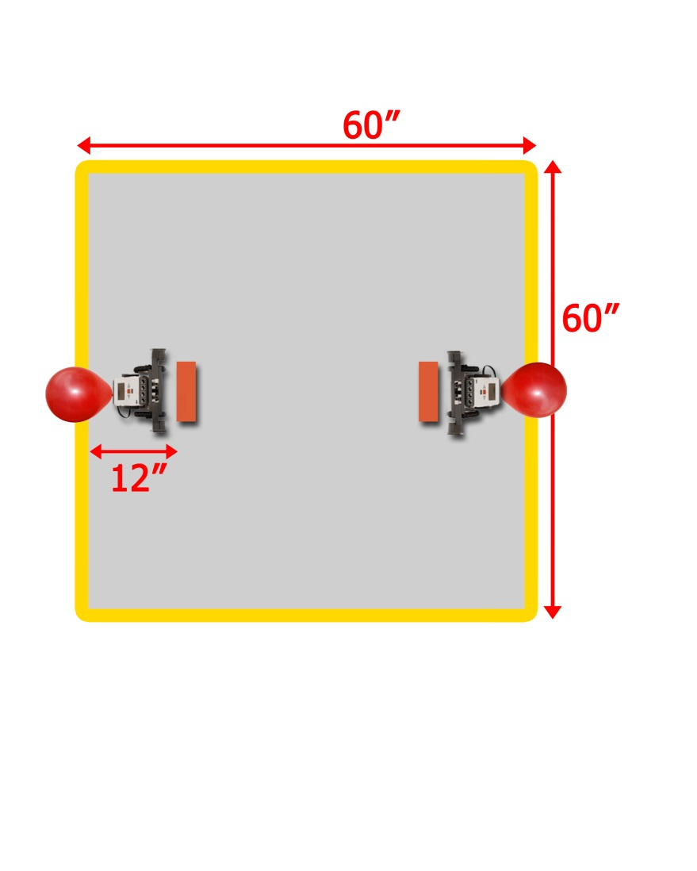

**Technical Requirements:**

* Vehicles must be constructed entirely with LEGO pieces (with the exception of the TWO THUMBTACKS and tape/glue to attach them).
* ***The robots may be controlled with a remote control program*** through Bluetooth such as the [NXT Remote Program](https://www.fresnou.org/sites/tot/project/_layouts/15/start.aspx#/SitePages/Community%20Home.aspx?RootFolder=%2Fsites%2Ftot%2Fproject%2FResources%2FEvent%20Tutorial%20Files%2F2015%20Robotics%20BattleBots&FolderCTID=0x01200065EE19DA9EDB2A4E8300DE56A78BB205&View=%7BAE0CE427%2D7E43%2D4D1D%2DB799%2DF18212EAB193%7D) (download the folder and extract to your desktop).
* Students may not touch the robot at all during each round. If there is a problem with the robot, it may ONLY be fixed in between rounds.
* There will be 30 seconds between rounds to make adjustments and reset.
* ONLY registered students are allowed to touch the robot and computer that is used.
* **The *entire robot* must fit inside a 12” x 12” x 12” box at the *start of each round***. **Pieces may *autonomously* extend out during the round.** (The balloon may extend out of the box).
* During a round, if ALL of a robot’s wheels are out of bounds the other team wins the round.
* No firing projectiles or dropping pieces onto the course. The robot should attempt to remain in one piece.

**Battle Bot Tournament Bracket:**

This event will consist of multiple “matches” as teams advance through the tournament bracket. We will try to do a double elimination bracket, depending on the number of teams that register. The tournament bracket and schedule will be posted online and in the event room. Students MUST be ready when they are up. If a team is not ready to compete within 2 minutes of being called, they will forfeit the match and potentially be eliminated from the competition.

**Matches:**Each “match” will be the best of three 90 second rounds. Each round will end as soon as a balloon is popped or a robot is pushed out of bounds. A point will be awarded to the first team to pop their opponent’s balloon or push them out of bounds. At the end of three rounds the team with the most points (2-1, 2-0, or 1-0) will win the match and move on to the next bracket. If no team has scored a point after three rounds, or if there is a 1-1 tie, there will be one final 30 second break and then sudden death will begin where the first to pop their opponent’s balloon OR push them out of bounds will win the match immediately.

**Reward Points:**

Teams will advance through the tournament bracket in an attempt to make it to the championship round and win the final match. 1st place will receive 70pts and each subsequent rank will receive 3 fewer points than the prior rank (2nd = 67pts, 3rd = 64pts, 4th = 61pts and so on).

|  |  |  |
| --- | --- | --- |
| **Battle Bots Scoring Breakdown** | | |
| Points from Rank | 70 | 70 – 3(Your Rank -1) |
| Points from Design Document | 30 | See Design Document on next page |
| **TOTAL POINTS** | **100** |  |

*Battle Bot Design Document*

**Overview:**  
Students will create a document outlining the process of designing and testing their robot. There will be four main sections: ***Research, Specifications, Programming and Testing***. The document will be submitted and scored prior to the tournament and will be worth 30 points. It must be uploaded to the [TOT site](https://www.fresnou.org/sites/tot/project/_layouts/15/start.aspx#/) no later than **March 6, 2015**

**Research:**

In this section students will use the internet or other sources to search for facts and information about ***Robotics in the Military***. They will need to provide specific examples of ***military robots*** and cite the sources they used for their research. Finally, they should describe how this research relates to their own project.

**Specifications:**

In this section students will list the dimensions of their robot (length, width, height) as well as a list of the primary components they used (motors and sensors). They will also include pictures of their robot.

**Programming:**

Students will explain how they controlled their robot to complete the task. They should state what program they used and discuss specific settings. They will also include a screenshot of the program.

**Testing:**

In the final section, students will describe the testing of their robot and what modifications they made to improve its speed, maneuverability and attack. This should include physical changes to the robot such as changing the wheels or redesigning the robot. It should also include changing the setting of the remote control program. Students should include a data table showing the results of different trials.

**Sample Data Table:**

|  |  |  |
| --- | --- | --- |
| **Trial** | **Win/Loss?** | **Modifications** |
| 1 | Win | Original battlebot design. |
| 2 | Win | Increased the speed of the motors to 90% |
| 3 | Loss | Used larger wheels on the robot, needed more friction. |
| 4 | Win | Reset the controls of the program to easier buttons for driving. |
| 5 | Loss | Redesigned the attack arm but it was too weak. |

If a team does not have another team to scrimmage against, they may simply list their modifications and how they improved/hindered their robot.

**Getting Help:**  
Visit the [Tournament of Technology Website](https://www.fresnou.org/sites/tot/project/_layouts/15/start.aspx#/SitePages/Community%20Home.aspx?RootFolder=%2Fsites%2Ftot%2Fproject%2FResources%2FEvent%20Tutorial%20Files%2F2015%20Robotics%20BattleBots&FolderCTID=0x01200065EE19DA9EDB2A4E8300DE56A78BB205&View=%7BAE0CE427%2D7E43%2D4D1D%2DB799%2DF18212EAB193%7D) to see a sample Design Document and our new [YouTube Channel](https://www.youtube.com/watch?v=OWAapHM1Dx0&list=PL_NqlViiP9nGPR8ILlv7jYJGRI4WzyEVB) to view tutorials to help prepare and practice. Contact Philip Siechert at [Philip.Siechert@fresnounified.org](mailto:Philip.Siechert@fresnounified.org) if you have any further questions regarding this event.

**Battle Bot Design Document Scoring Rubric** **Team:___________________________**

|  |  |  |  |  |  |
| --- | --- | --- | --- | --- | --- |
| **Category** | Exemplary | Proficient | Partially Proficient | Incomplete | Points |
| **RESEARCH:** | | | | | |
| **There are specific examples provided.** | **5 points**  3 or more very relevant examples are provided. | **3 points**  2-3 relevant examples are provided. | **1 point**  Only 1 somewhat relevant example is provided. | **0 points**  There were no examples provided. |  |
| **Multiple reliable sources have been referenced or cited in the research.** | **5 points**  3 or more very reliable sources have been referenced or cited in the research. | **3 points** 2 reliable sources have been referenced or cited in the research. | **1 point**  Just 1 somewhat reliable source was referenced or cited in the research. | **0 points**  There were no sources referenced or cited in the research. |  |
| **SPECIFICATIONS:** | | | | | |
| **The dimensions and components of the robot are clearly listed with multiple pictures.** | **5 points**  All dimensions/components are listed and there are 3 or more pictures of the robot. | **3 points**  Dimensions/components are listed and there are 2 pictures. | **1 point**  Missing dimensions or components and has just 1 picture. | **0 points**  Missing dimensions and components and there are no pictures. |  |
| **PROGRAMMING:** |  |  |  |  |  |
| **It is very clear how the programming makes the robot complete the tasks.** | **5 points**  It is very clear how the programming works. | **3 points**  It is somewhat clear how the programming works. | **1 point**  It is unclear how the programming works. | **0 points**  There is no explanation of the programming at all. |  |
| **TESTING:** |  |  |  |  |  |
| **There was significant testing to improve the speed, maneuverability, and attack of the robot.** | **5 points**  5 or more modifications were very clearly described in the testing. | **3 points**  3 modifications were clearly described in the testing. | **1 point**  Fewer than 3 modifications were somewhat described in the testing. | **0 points**  There were no adjustments or modifications described in the testing. |  |
| **A clear and detailed data table was included to show results of the testing.** | **5 points**  The data table was very clear and easy to read with multiple entries and detailed results. | **3 points**  The data table was clear with but lacked specific detail. | **1 point**  The data table was confusing and lacked detail. | **0 points**  There was no data table in the design document. |  |

**Total Score _____  
 (30 max)**

**Lego Robotics**

*Main Event: Block Bot*

**Event Description**Teams of 2-3 students will create a robot, using only the kits provided and any other LEGO pieces, prior to the day of the tournament. A remote control program may be used to move and control the robot on the course. On the day of competition they will race to determine who can complete the course with the best score and time. (see scoring section below). A perfect score will require all blocks to be successfully transferred without knocking down any of the starting towers. (see course description below).

**Common Core Standards and 4C’s:**

Prepare for and participate effectively in a range of conversations and collaborations with diverse partners, building on others’ ideas and expressing their own ideas clearly and persuasively. Creativity, Collaboration, Communication and Critical Thinking.

**Designing and Programming your Robot:  
*Design Specifications:***

Your robot will need to be able to drive around on a course and attempt to pick up and carry colored blocks from white starting towers (3 ¾” tall) to their matching colored base (3 5/8” tall). Each block is approximately 1 ½“ x 1 ½” x 1 ½”. The bases vary in difficulty starting with the easiest a 3 ½” x 3 ½” red base, then a 1 ½” x 1 ½” yellow base, a 1” x 1” blue base, and finally a ¾” x ¾” green base.

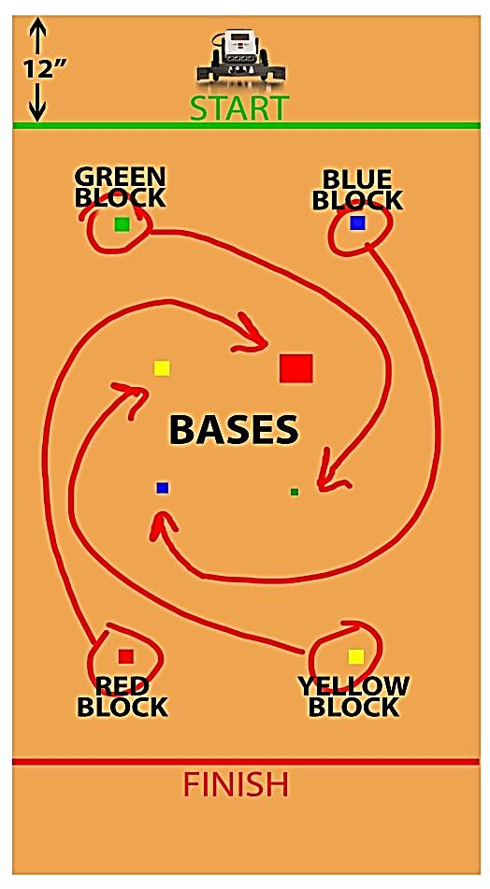

***Course Layout***

The course will consist of a 4’x8’ plywood panel (the back side of the Line Follower Course). There will be a starting line and a finish line each located 12” from the edge of the board.

The four white starting towers will be located at least 12” from the edges of the course and at least 12” from the base blocks located in the center. Each of the starting towers will have a different colored block positioned on top at the start of the challenge.

The four colored bases will be arranged in the center of the course so that they are as far away from their matching block as possible. They will also be positioned at least 12” from one another.

You may choose to travel around the base blocks, or navigate through them and may complete the course in any order. (see image at left)

**Technical Requirements:**

* Vehicles must be constructed entirely with LEGO pieces.
* The entire robot must fit behind the starting line, 12” from the edge of the course.
* ***The robots may be controlled with a remote control program*** through Bluetooth such as the [NXT Remote Program](https://www.fresnou.org/sites/tot/project/_layouts/15/start.aspx#/SitePages/Community%20Home.aspx?RootFolder=%2Fsites%2Ftot%2Fproject%2FResources%2FEvent%20Tutorial%20Files%2F2015%20Robotics%20BlockBots&FolderCTID=0x01200065EE19DA9EDB2A4E8300DE56A78BB205&View=%7BAE0CE427%2D7E43%2D4D1D%2DB799%2DF18212EAB193%7D) (download the folder and extract to your desktop).
* Time will start as soon as the robot crosses the starting line and time will stop as soon as it crosses the finish line.
* Teams will have 5 minutes to complete the course as many times as possible. The best score and time combination will be used to calculate the FINAL SCORE (see scoring section).
* ONLY registered students are allowed to touch the robot and computer that is used. (If a situation such as laptop failure arises, then the coach can inform a contest official and receive approval before entering the team competition area.)
* Live student problem-solving is the spirit of this competition.

**Scoring:**

Scores will be a combination of the points awarded from successfully completing the course AND from the time it takes to finish. The majority of the points come from transferring the blocks which should be your priority. Time will mostly be used to help split ties, along with points from the Design Document.

***Points from Course:***

Successfully transferring the red block 8pts

Successfully transferring the yellow block 12pts

Successfully transferring the blue block 16pts

Successfully transferring the green block 20pts

Leaving up all 4 starting towers (1pt each) 4pts

**TOTAL 60pts**

***Points from Time:***

Up to 10 points will be awarded based off of your time as a ratio to the best time of all competitors. The time used will be from whichever round you scored the most points from the course.

|  |  |  |
| --- | --- | --- |
| **Lego Robotics Scoring Breakdown** | | |
|  | Max Points | Formula |
| Points from COURSE | 60 | See List Above |
| Points from TIME | 10 | First Place Time  ---------------------- X 10  Your TIME |
| Points from Design Document | 30 | See Next Page |
| **TOTAL POINTS** | **100** |  |

*Block Bot Design Document*

**Overview:**  
Students will create a document outlining the process of designing and testing their robot. There will be four main sections: ***Research, Specifications, Programming and Testing***. The document will be submitted and scored prior to the tournament and will be worth 30 points. It must be uploaded to the [TOT site](https://www.fresnou.org/sites/tot/project/_layouts/15/start.aspx#/) no later than **March 6, 2015**.

**Research:**

In this section students will use the internet or other sources to search for facts and information about ***Robotics in Medicine***. They will need to provide specific examples of ***medical robots*** and cite the sources they used for their research. Finally, they should describe how this research relates to their own project.

**Specifications:**

In this section students will list the dimensions of their robot (length, width, height) as well as a list of the primary components they used (motors and sensors). They will also include pictures of their robot.

**Programming:**

Students will explain how they controlled their robot to complete the task. They should state what program they used and discuss specific settings. They will also include a screenshot of the program.

**Testing:**

In the final section, students will describe the testing of their robot and what modifications they made to improve its speed and accuracy. This should include physical changes to the robot such as changing the wheels or redesigning the robot. It should also include changing the setting of the remote control program. Students should include a data table showing the results of different trials.

**Sample Data Table:**We only included times of trials that were completed successfully without dropping any blocks or knocking down any of the starting towers.

|  |  |  |
| --- | --- | --- |
| **Trial** | **Time** | **Adjustments** |
| 1 | 4:57 | First successful completion of the course. |
| 2 | 3:42 | Increased the speed of the motors to 90% |
| 3 | 3:30 | Used larger wheels on the robot. |
| 4 | 3:10 | Reset the controls of the program to easier buttons for driving. |
| 5 | 2:57 | Improved speed by practicing driving with a partner controlling the arm. |

**Getting Help:**  
Visit the [Tournament of Technology Website](https://www.fresnou.org/sites/tot/project/_layouts/15/start.aspx#/SitePages/Community%20Home.aspx?RootFolder=%2Fsites%2Ftot%2Fproject%2FResources%2FEvent%20Tutorial%20Files%2F2015%20Robotics%20BlockBots&FolderCTID=0x01200065EE19DA9EDB2A4E8300DE56A78BB205&View=%7BAE0CE427%2D7E43%2D4D1D%2DB799%2DF18212EAB193%7D) to see a sample Design Document and our new [YouTube Channel](https://www.youtube.com/watch?v=OWAapHM1Dx0&list=PL_NqlViiP9nGPR8ILlv7jYJGRI4WzyEVB) to view tutorials to help prepare and practice.

Contact Philip Siechert at [Philip.Siechert@fresnounified.org](mailto:Philip.Siechert@fresnounified.org) if you have any further questions regarding this event.

**Block Bot Design Document Scoring Rubric** **Team:___________________________**

|  |  |  |  |  |  |
| --- | --- | --- | --- | --- | --- |
| **Category** | Exemplary | Proficient | Partially Proficient | Incomplete | Points |
| **RESEARCH:** | | | | | |
| **There are specific examples provided.** | **5 points**  3 or more very relevant examples are provided. | **3 points**  2-3 relevant examples are provided. | **1 point**  Only 1 somewhat relevant example is provided. | **0 points**  There were no examples provided. |  |
| **Multiple reliable sources have been referenced or cited in the research.** | **5 points**  3 or more very reliable sources have been referenced or cited in the research. | **3 points** 2 reliable sources have been referenced or cited in the research. | **1 point**  Just 1 somewhat reliable source was referenced or cited in the research. | **0 points**  There were no sources referenced or cited in the research. |  |
| **SPECIFICATIONS:** | | | | | |
| **The dimensions and components of the robot are clearly listed with multiple pictures.** | **5 points**  All dimensions/components are listed and there are 3 or more pictures of the robot. | **3 points**  Dimensions/components are listed and there are 2 pictures. | **1 point**  Missing dimensions or components and has just 1 picture. | **0 points**  Missing dimensions and components and there are no pictures. |  |
| **PROGRAMMING:** |  |  |  |  |  |
| **It is very clear how the programming makes the robot complete the tasks.** | **5 points**  It is very clear how the programming works. | **3 points**  It is somewhat clear how the programming works. | **1 point**  It is unclear how the programming works. | **0 points**  There is no explanation of the programming at all. |  |
| **TESTING:** |  |  |  |  |  |
| **There was significant testing to improve the speed/accuracy of the robot.** | **5 points**  5 or more modifications were very clearly described in the testing. | **3 points**  3 modifications were clearly described in the testing. | **1 point**  Fewer than 3 modifications were somewhat described in the testing. | **0 points**  There were no adjustments or modifications described in the testing. |  |
| **A clear and detailed data table was included to show results of the testing.** | **5 points**  The data table was very clear and easy to read with multiple entries and detailed results. | **3 points**  The data table was clear with but lacked specific detail. | **1 point**  The data table was confusing and lacked detail. | **0 points**  There was no data table in the design document. |  |

**Total Score _____  
 (30 max)**

**Lego Robotics**

*Main Event: Line Follower*

**Event Description**Teams of 2-3 students will design, build and program an original robot, using the kits provided and any other LEGO pieces, prior to the day of the tournament. On the day of competition they will race to determine who can complete the course the fastest. A bonus will be awarded for firing a missile over the brick and landing on a target on the other side.

**Common Core Standards and 4C’s:**

Prepare for and participate effectively in a range of conversations and collaborations with diverse partners, building on others’ ideas and expressing their own ideas clearly and persuasively. Creativity, Collaboration, Communication and Critical Thinking.

**Designing and Programming your Robot:  
*Sensors and Programming***

The light sensor will be needed to locate the black line. It can be programmed to move the robot forward if it sees black (below certain brightness) or move back/to the side if it sees the white (above the certain brightness). The Robot MUST remain on the path at all times.

The push sensor will be needed to identify the brick at the end of the course. It can be programmed to tell the third motor to release the missile upon touching the brick. (Alternatively, the ultrasonic sensor could be used to locate the brick.) *Time will not stop until the robot comes in contact with the brick.*

***Course Layout***

Robots will be required to navigate a course on a white vinyl plywood board. There will be a piece of black tape (1.88” width) that the robots must follow to the finish. If the robot leaves the path, it must restart at the beginning (the time will also be restarted). Students will have 5 minutes to try as many times as possible. Their best time will be recorded as their score.

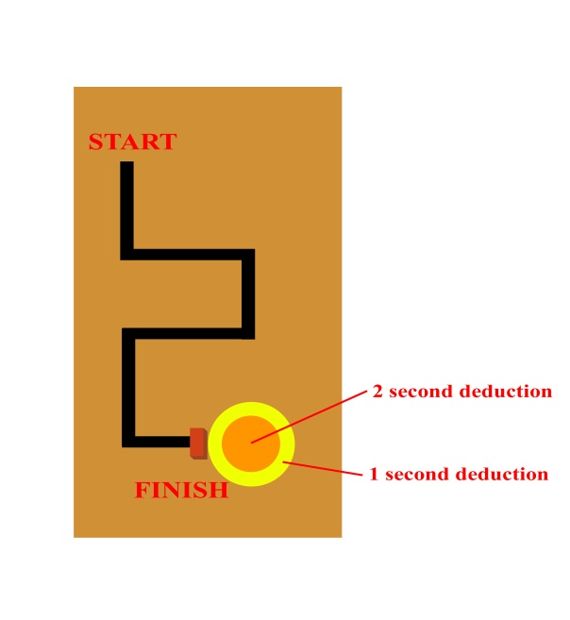The final course will be revealed on the day of the event. It will consist of all straight pieces of tape with at least four 90 degree turns. No section will be shorter than 12 inches and will always be at least 9 inches away from the edge of the board. The finish will be marked with a **3 ½” high x 7 ½” wide x 2 ¼” thick** brick that the robot must touch. Time will stop ***as soon as*** the robot touches the brick, it may still fire the missile ***after*** touching the brick.

***Sample Course:***

This is only a sample course, the actual course will have

different turns in a different order. Turns may not be exactly 90 degrees. The target will be on the other side of the brick directly in line with the tape, with the center exactly 9 inches from the back of the brick.

***Bonus Objectives: Missile Shooting!***

On the other side of the brick there will be a target that the robot will shoot at using the missile piece. Time will be deducted from the finish time for landing on the target. The center of the target will be exactly 9 inches from the back side of the brick. There will be two rings to the target, a 12” diameter ring worth 2 seconds, and an 18” diameter ring worth 1 second. The final resting place of the missile will be used to determine the deduction. The **black rubber tip** of the missile ***may be modified*** in any way with any material to reduce the bounce. If the missile lands on the edge of two rings, the higher scored ring will be counted. Only parts of the **original missile** count for scoring. String may be used to fire the missile.

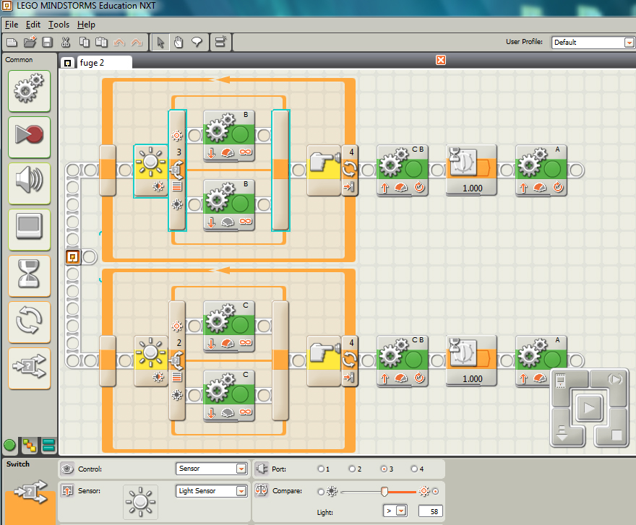 ***Sample Programming:***

This is a sample program for the course.

It uses two light sensors to check each side of the line. Each sensor controls one of the motors. If the left sensor sees the line, it tells the left motor to slow down, so the robot corrects itself.

The light sensors are programmed in a loop to continually check to see if they are touching the line. The loop is running until the touch sensor is triggered by the finish wall, at which point it backs up and fires the missile.

**Technical Requirements:**

The projects must have an obvious relationship to the computer and be controlled through student created programming using the Mindstorm software. Once started, the program must run **independently** through the entire course (no remote controlled robots).

* There will be a 5 minute time limit on all entries.
* ONLY registered students are allowed to touch the robot and computer that is used.
* The entire robot must fit behind the starting line, 12” from the edge of the course
* Robots must be constructed entirely with LEGO pieces, string is allowed to fire the missile.
* Extra items may NOT be used to enhance the stability, functionality, or aesthetics of your robot.

**Reward Points:**

This event will use the best finish time and target deduction combination to calculate the FINAL TIME.

Final times from all teams will be ranked and entered into a spreadsheet to calculate points.

|  |  |  |
| --- | --- | --- |
|  | Max Points | Formula |
| Points from FINAL TIME | 35 | First Place Time  ---------------------- X 35  Your FINAL TIME |
| Points from Rank | 35 | 35 – 3(Your Rank -1) |
| Points from Design Document | 30 | See Design Document on next page. |
| **TOTAL POINTS** | **100** |  |

*Line Follower Design Document*

**Overview:**  
Students will create a document outlining the process of designing and testing their robot. There will be four main sections: ***Research, Specifications, Programming and Testing***. The document will be submitted and scored prior to the tournament and will be worth 30 points. It must be uploaded to the [TOT site](https://www.fresnou.org/sites/tot/project/_layouts/15/start.aspx#/) no later than **March 6, 2015**.

**Research:**

In this section students will use the internet or other sources to search for facts and information about ***self-driving cars***. They will need to provide specific examples of ***self-driving cars*** and cite the sources they used for their research. Finally, they should describe how this research relates to their own project.

**Specifications:**

In this section students will list the dimensions of their robot (length, width, height) as well as a list of the primary components they used (motors and sensors). They will also include pictures of their robot.

**Programming:**

Students will explain how they programmed their robot to complete the task. Their explanation should include specific blocks and settings. They will also include a screenshot of their program.

**Testing:**

In the final section, students will describe the testing of their robot and what modifications they made to improve its speed and accuracy. This should include physical changes to the robot such as changing the wheels or redesigning the robot. It should also include changes to the programming. Students should include a data table showing the results of different trials.

**Sample Data Table:**

|  |  |  |
| --- | --- | --- |
| **Trial** | **Time** | **Adjustments** |
| 1 | 10.2 s | First successful completion of the course. |
| 2 | 9.2 s | Increased the distance between the sensors to 14cm. |
| 3 | 9.7 s | Decreased the distance between the sensors to 12cm. |
| 4 | 8.9 s | Increased the power on the motors to 80% |
| 5 | 9.4 s | Increased the power on the motors to 90% |
| 6 | 7.2 s | Used the larger wheels on the robot. |

**Getting Help:**  
Visit the [Tournament of Technology Website](https://www.fresnou.org/sites/tot/project/_layouts/15/start.aspx#/SitePages/Community%20Home.aspx?RootFolder=%2Fsites%2Ftot%2Fproject%2FResources%2FEvent%20Tutorial%20Files%2F2015%20Robotics%20LineFollower&FolderCTID=0x01200065EE19DA9EDB2A4E8300DE56A78BB205&View=%7BAE0CE427%2D7E43%2D4D1D%2DB799%2DF18212EAB193%7D) to see sample programming and a sample Design Document. Go to our new [YouTube Channel](https://www.youtube.com/watch?v=OWAapHM1Dx0&list=PL_NqlViiP9nGPR8ILlv7jYJGRI4WzyEVB) to view tutorials to help prepare and practice.

Contact Philip Siechert at [Philip.Siechert@fresnounified.org](mailto:Philip.Siechert@fresnounified.org) if you have any further questions regarding this event.

**Line Follower Design Document Scoring Rubric** **Team:___________________________**

|  |  |  |  |  |  |
| --- | --- | --- | --- | --- | --- |
| **Category** | Exemplary | Proficient | Partially Proficient | Incomplete | Points |
| **RESEARCH:** | | | | | |
| **There are specific examples provided.** | **5 points**  3 or more very relevant examples are provided. | **3 points**  2-3 relevant examples are provided. | **1 point**  Only 1 somewhat relevant example is provided. | **0 points**  There were no examples provided. |  |
| **Multiple reliable sources have been referenced or cited in the research.** | **5 points**  3 or more very reliable sources have been referenced or cited in the research. | **3 points** 2 reliable sources have been referenced or cited in the research. | **1 point**  Just 1 somewhat reliable source was referenced or cited in the research. | **0 points**  There were no sources referenced or cited in the research. |  |
| **SPECIFICATIONS:** | | | | | |
| **The dimensions and components of the robot are clearly listed with multiple pictures.** | **5 points**  All dimensions/components are listed and there are 3 or more pictures of the robot. | **3 points**  Dimensions/components are listed and there are 2 pictures. | **1 point**  Missing dimensions or components and has just 1 picture. | **0 points**  Missing dimensions and components and there are no pictures. |  |
| **PROGRAMMING:** |  |  |  |  |  |
| **It is very clear how the programming makes the robot complete the tasks.** | **5 points**  It is very clear how the programming works. | **3 points**  It is somewhat clear how the programming works. | **1 point**  It is unclear how the programming works. | **0 points**  There is no explanation of the programming at all. |  |
| **TESTING:** |  |  |  |  |  |
| **There was significant testing to improve the speed/accuracy of the robot.** | **5 points**  5 or more modifications were very clearly described in the testing. | **3 points**  3 modifications were clearly described in the testing. | **1 point**  Fewer than 3 modifications were somewhat described in the testing. | **0 points**  There were no adjustments or modifications described in the testing. |  |
| **A clear and detailed data table was included to show results of the testing.** | **5 points**  The data table was very clear and easy to read with multiple entries and detailed results. | **3 points**  The data table was clear with but lacked specific detail. | **1 point**  The data table was confusing and lacked detail. | **0 points**  There was no data table in the design document. |  |

**Total Score _____  
 (30 max)**

**Lego Robotics**

*Main Event: Robo Rally*

**Event Description**Teams of 2-3 students will design and build a robot, using the kits provided and any other LEGO pieces. Robots must be programmed to do a number of different tasks. On the day of competition they will face off against other teams in 1 on 1 matches to advance through a tournament bracket to the final match.

**Common Core Standards and 4C’s:**

Prepare for and participate effectively in a range of conversations and collaborations with diverse partners, building on others’ ideas and expressing their own ideas clearly and persuasively. Creativity, Collaboration, Communication and Critical Thinking.

**Designing and Programming your Robot:**

Robots must be built and programmed to complete a number of different “missions” on the course. For this event, robots will be required to complete each mission autonomously, not remote controlled. Missions may be completed in any order and may be attempted multiple times during the 3 minute match. Teams may choose to swap out parts and reprogram the robot during the match.

***Course Layout:***

The course will consist of a 4’x8’ playing area split lengthwise, as shown below with a ¾” thick and 3 ½” tall border on all sides. [(Click here for detailed course measurements)](https://www.fresnou.org/sites/tot/project/_layouts/15/WopiFrame.aspx?sourcedoc=/sites/tot/project/Resources/Event%20Tutorial%20Files/2015%20Robotics%20RoboRally/Robo%20Rally%20Dimension%20Sheet.docx&action=default)

Each team will have a ***home base area***, where they are allowed to rebuild/reprogram their robot. The robot must start each mission **entirely**within the home base area. If a team’s robot fails to return to the home base by itself, there will be a 20 second penalty enforced during which they may not touch their robot. Teams are not allowed to touch the robot unless it has at least 1 wheel in the home base area.

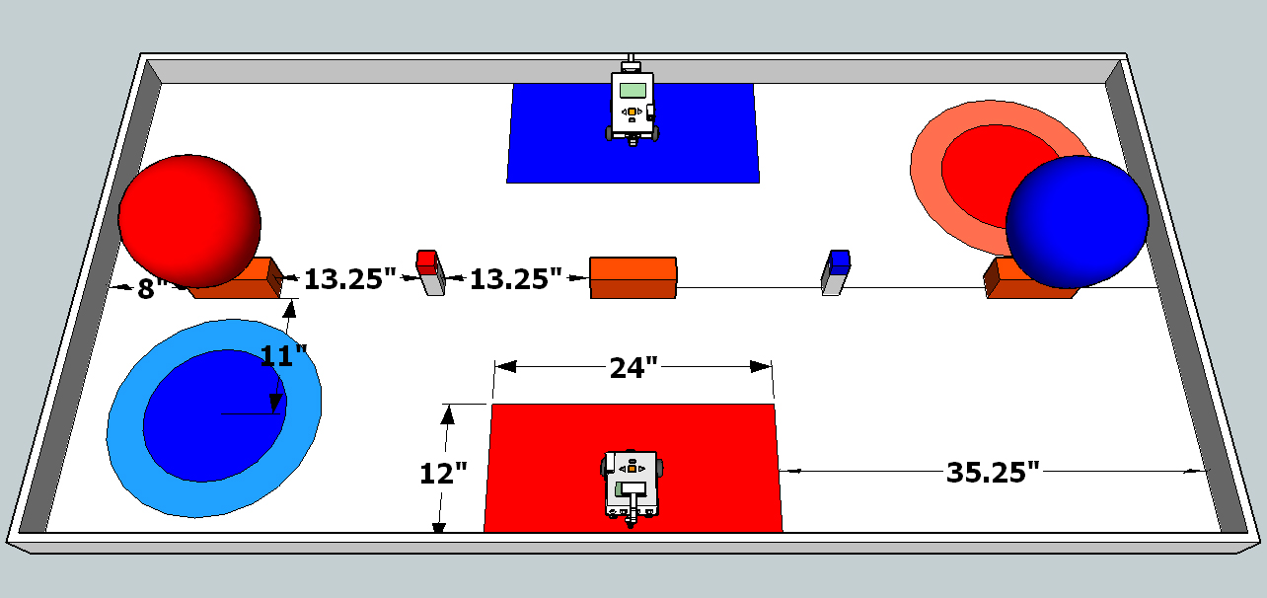

*Missions:****Balloon Pop (1pt):*** the robot must autonomously drive over and pop the balloon. Red team pops red balloon, blue team pops blue balloon. We will be using standard 12” balloons.  
***Block Transfer (2pts):*** the robot must autonomously drive over to pick up the block and then place it on the center brick. Red team moves red block, blue team moves blue block. Blocks will be replaced on the starting towers if they are dropped or fall off the brick.  
***Missile Launch (up to 4pts):*** the robot must autonomously drive to a shooting location and fire a missile to land in the target on the other side. 2 points if it lands in the center, 1 point if it lands in the outer ring. Teams may use 2 missiles during the challenge. The final resting place of the missile will be used to determine points. The black rubber tip of the missile may be modified in any way with any material to reduce the bounce. Only parts of the original missile count for scoring. If the missile lands on the edge of two rings, the higher scored ring will be counted. Teams may retrieve their missiles if they are not in the target, or if they want to retry for the center target. String may be used to fire missiles.  
***Block Launch (3pts):*** Teams may choose to launch their block off the course for 3pts instead of transferring it. To complete this challenge teams must design and 3D print an attachment to retrieve the block. The attachment must connect to the robot on its own (no other materials/substances may be used). There will be a hole in the block for the attachment to go through. The robot must get the block completely off the course (over the 3.5” tall border). The robot must be entirely outside of the home base area when launching the block. Once the block is off the course, it is a guaranteed 3 points.

**Teams may also try to reduce their opponents’ score by choosing the following missions:  
*Block Bash***: the robot must autonomously drive to the center brick and push the opponent’s block off the brick. Blocks that are pushed off will be returned to their starting tower.  
***Missile Sweep***: the robot must autonomously drive to the opposing team’s target and push their missile out of the target area. Missiles that are pushed out of the target will be returned to the team. **Sudden Death:**  
If there is a tie in score at the end of the 3 minute match, sudden death will be enforced, where the first team to score a point wins. The entire course will be reset for the sudden death round. Teams will have 1 minute to plan/rebuild their robot before the sudden death round starts. **Technical Requirements:**   
Robots must be constructed entirely with LEGO pieces with the exception of 1 thumbtack, tape/glue to attach it to the robot and string to fire the missile. Robots may return to the home base area between missions to be reprogrammed or rebuilt for another mission or they may do more than one at a time.

* There will be a 3 minute time limit on each match.
* Robots must complete the missions autonomously, no remote controlled robots.
* ***Missiles and blocks must remain in a scoring position at the END of the match to earn points.***
* No team member may interfere with or touch the opposing team’s robot.
* The entire robot must start within the home base area for each mission attempted.
* Robots must remain on their own side of the course. A 20 second penalty will be enforced if 2 or more of the robot’s wheels cross the center line.

**Reward Points:**

Teams will advance through the tournament bracket in an attempt to make it to the championship round and win the final match. 1st place will receive 70pts and each subsequent rank will receive 3 fewer points than the prior rank (2nd = 67pts, 3rd = 64pts, 4th = 61pts and so on).

|  |  |  |
| --- | --- | --- |
| Points from Rank | 70 | 70 – 3(Your Rank -1) |
| Points from Design Document | 30 | See Design Document on next page |
| **TOTAL POINTS** | **100** |  |

*Robo Rally Design Document*

**Overview:**  
Students will create a document outlining the process of designing and testing their robot. There will be four main sections: ***Research, Specifications, Programming and Testing***. The document will be worth 30 points. It must be uploaded to the [TOT site](https://www.fresnou.org/sites/tot/project/_layouts/15/start.aspx#/) no later than **March 6, 2015**.

**Research:**

In this section students will use the internet or other sources to search for facts and information about ***robotic space exploration***. They should provide specific examples of ***robots in space*** and cite the sources they used for their research. Finally, they should describe how this research relates to their own project.

**Specifications:**

In this section students will list the dimensions of their robot (length, width, height) as well as a list of the primary components they used (motors and sensors). They will also include pictures of their robot. If there are different configurations for the different missions be sure to show them.

**Programming:**

Students will explain how they programmed their robot to complete the different tasks. Their explanation should include specific blocks and settings and screenshots of their programs.

**Testing:**

In the final section, students will describe the testing of their robot and what modifications they made to improve its speed and accuracy. This should include physical changes to the robot such as changing the wheels, modifications to the missile or even redesigning the robot. It should also include changes to the programming. Students should include a data table showing the results of different trials.

**Sample Data Table: (Should have one for each Mission)**

|  |  |  |
| --- | --- | --- |
| **Trial** | **Time** | **Adjustments** |
| 1 | 4.2 s | First successful completion of balloon pop mission. |
| 2 | 3.2 s | Increased the power on the motors to 100% |
| 3 | 2.7 s | Used the larger wheels on the robot. |

**Getting Help:**  
Visit the [Tournament of Technology Website](https://www.fresnou.org/sites/tot/project/_layouts/15/start.aspx#/SitePages/Community%20Home.aspx?RootFolder=%2Fsites%2Ftot%2Fproject%2FResources%2FEvent%20Tutorial%20Files%2F2015%20Robotics%20RoboRally&FolderCTID=0x01200065EE19DA9EDB2A4E8300DE56A78BB205&View=%7BAE0CE427%2D7E43%2D4D1D%2DB799%2DF18212EAB193%7D) to see a sample Design Document and our new [YouTube Channel](https://www.youtube.com/watch?v=OWAapHM1Dx0&list=PL_NqlViiP9nGPR8ILlv7jYJGRI4WzyEVB) to view tutorials to help prepare and practice. Contact Philip Siechert at [Philip.Siechert@fresnounified.org](mailto:Philip.Siechert@fresnounified.org) if you have any further questions regarding this event.

**Robo Rally Design Document Scoring Rubric** **Team:___________________________**

|  |  |  |  |  |  |
| --- | --- | --- | --- | --- | --- |
| **Category** | Exemplary | Proficient | Partially Proficient | Incomplete | Points |
| **RESEARCH:** | | | | | |
| **There are specific examples provided.** | **5 points**  3 or more very relevant examples are provided. | **3 points**  2-3 relevant examples are provided. | **1 point**  Only 1 somewhat relevant example is provided. | **0 points**  There were no examples provided. |  |
| **Multiple reliable sources have been referenced or cited in the research.** | **5 points**  3 or more very reliable sources have been referenced or cited in the research. | **3 points** 2 reliable sources have been referenced or cited in the research. | **1 point**  Just 1 somewhat reliable source was referenced or cited in the research. | **0 points**  There were no sources referenced or cited in the research. |  |
| **SPECIFICATIONS:** | | | | | |
| **The dimensions and components of the robot are clearly listed with multiple pictures.** | **5 points**  All dimensions/components are listed and there are 3 or more pictures of the robot. | **3 points**  Dimensions/components are listed and there are 2 pictures. | **1 point**  Missing dimensions or components and has just 1 picture. | **0 points**  Missing dimensions and components and there are no pictures. |  |
| **PROGRAMMING:** |  |  |  |  |  |
| **It is very clear how the programming makes the robot complete the tasks.** | **5 points**  It is very clear how the programming works. | **3 points**  It is somewhat clear how the programming works. | **1 point**  It is unclear how the programming works. | **0 points**  There is no explanation of the programming at all. |  |
| **TESTING:** |  |  |  |  |  |
| **There was significant testing to improve the speed/accuracy of the robot.** | **5 points**  5 or more modifications were very clearly described in the testing. | **3 points**  3 modifications were clearly described in the testing. | **1 point**  Fewer than 3 modifications were somewhat described in the testing. | **0 points**  There were no adjustments or modifications described in the testing. |  |
| **A clear and detailed data table was included to show results of the testing.** | **5 points**  The data table was very clear and easy to read with multiple entries and detailed results. | **3 points**  The data table was clear with but lacked specific detail. | **1 point**  The data table was confusing and lacked detail. | **0 points**  There was no data table in the design document. |  |

**Total Score _____  
 (30 max)**

**Video Production**

*Main Event: Advertisement*

**Event Description:**

Teams of 2-4 students will collaborate with a local business owner to produce a digital video advertisement. Ads should be sensitive to the purpose and targeted to specific demographic. Be sure to include information as applicable to the business (i.e., location, hours, etc.) Ads should engage the viewer and promote the local business positively.

**Common Core Standards:**

Present claims and findings, emphasizing salient points in a focused, coherent manner with pertinent descriptions, facts, details, and examples.

**Designing and Creating your Project:**

The process of creating your project should take on the following steps:

1. Connecting with a Local Business – Find a local business to participate and have students interview the manager or owner.
2. Prepare the Script – Write down a script that would include a narrative and describe the scene.
3. Produce a Storyboard – Use cards, pictures, or drawings to represent the sequence of the shots for your project.
4. Shooting the Project – The actual shooting of the video and pictures to be used in the project.
5. Video Editing – Software will be used to edit video and mix in sound, graphics, and animation.

**Technical Requirements:**

* Any video editing software (iMovie, Windows Movie Maker, Adobe Premiere, etc.) can be used.
* Please try to upload videos as an mp4 format. Free online video converter: [freemake](http://www.freemake.com/) or [zamzar](http://www.zamzar.com/).
* Final project must be submitted by **Friday March 6th 2015** to the [TOT website](https://www.fresnou.org/sites/tot/project/_layouts/15/start.aspx#/).
* The video file needs to be less than 100 MB.
* The video needs to be 30 seconds exactly.
* Complete all release forms for likenesses and locations.
* Follow all copyright requirements.

**Reward Points:**  
***5****pts* - The ad meets the time limit requirement of 30 seconds exactly.  
***5****pts* - The ad has been made in collaboration with a local business.

***5****pts* - The ad clearly shows the products or services being advertised**.**  
***10****pts* - The ad persuades the viewer to become a consumer of the products/service being advertised. ***10****pts* - The ad demonstrates an understanding of persuasive techniques   
***10****pts* - Music selection matches the tone of the video.  
***10****pts* - General audio quality is balanced throughout the film.

***15****pts* - Film follows basic film techniques and is well executed  
***30****pts* – Live Challenge (see next page)

*Live Challenge: Story(board) Time*

**Scenario:**  
In this event your team of 2 or 4 students will produce a storyboard for an advertisement about some type of product. The team will be given a name of a product and a description of a product with a list of a few points the company wants to emphasize. Using whiteboards and dry erase markers, the team will collaborate to produce the storyboard and plan their presentation.

**Challenge:**

* Storyboards need to show the sequence of the shots for the commercial.
* Storyboard frames need to show an idea of the camera view for each shot.
* During the presentation, the team does not have to have a word for word script. However, they should generally tell what is going on and being said in each storyboard frame.

**Time:** Your team will have:

* 15 minutes to brainstorm AND create your storyboard
* 2 minutes to present your storyboard to the judges

**Scoring:** You will receive up to:  
***6****pts* – Team collaboration during the planning stage.  
***6****pts* – Creativity of the presentation.  
***6****pts* – Incorporation of all team members into the presentation  
***6****pts* – There was a variety of appropriate camera views in the storyboards.  
***6****pts* – The points that the company wanted to emphasize were done well during the presentation

**Tips:**  
As with most of the live challenges, teams will need to be very careful with time management. They should allocate at least a few minutes to review their storyboard and prepare for the presentation to the judges.

**Getting Help:**  
Visit the [Tournament of Technology Website](https://www.fresnou.org/sites/tot/project/_layouts/15/start.aspx#/SitePages/Community%20Home.aspx?RootFolder=%2Fsites%2Ftot%2Fproject%2FResources%2FEvent%20Tutorial%20Files%2F2015%20Video%20Ad&FolderCTID=0x01200065EE19DA9EDB2A4E8300DE56A78BB205&View=%7BAE0CE427%2D7E43%2D4D1D%2DB799%2DF18212EAB193%7D) for sample Live Challenges and our new [YouTube Channel](https://www.youtube.com/watch?v=HGfIQDTagIg&list=PL_NqlViiP9nECGF9ZLFF2YX_7EjYhG1Uv) to view tutorial videos to help prepare and practice.

Contact Jackie Burger at [Jackie.burger@fresnounified.org](mailto:Jackie.burger@fresnounified.org) or Ryan Coe at [ryan.coe@fresnounified.org](mailto:ryan.coe@fresnounified.org) if you have any further questions about this event.

**Advertisement Scoring Rubric Team:_______________________**

|  |  |  |  |  |  |
| --- | --- | --- | --- | --- | --- |
| **Category** | Exemplary | Proficient | Partially Proficient | Incomplete | Points |
| **The ad meets the time limit requirement of 30 seconds exactly.** | **5 points**  The ad is 30 seconds exactly. | **4 points**  The ad is + or – 0.5 seconds. | **3 points**  The ad is + or – 1 second. | **1 point**  The ad is + or – 2 or more seconds. |  |
| **The ad has been made in collaboration with a local business.** | **5 points**  There is strong evidence that there was collaboration. | **3 points**  The evidence is satisfactory that there was collaboration. | **1 point**  The evidence is weak that there was collaboration. | **0 points**  There is no evidence that there was collaboration. |  |
| **The ad clearly shows the products or services being advertised.** | **5 points**  The ad very clearly shows the products or services being advertised throughout the film. | **3 points**  The ad clearly shows the products or services being advertised. | **2 points**  The ad is vague about the products or services being advertised. | **1 points**  It is not clear about the product or service is that is being advertised. |  |
| **The ad persuades the viewer to become a consumer of the products/service being advertised.** | **10 points**  The ad convinces the viewer to become a consumer of the product/service right from the start. | **7 points**  The ad tries to convince the viewer to become a consumer of the product/service. | **4 points**  The ad doesn’t do much to convince the viewer to become a consumer of the product/service. | **1 point**  The ad is not appealing enough to convince the viewer to become a consumer of the product/service. |  |
| **The ad demonstrates an understanding of persuasive techniques (band wagon, testimonial, emotional appeal, irony, repetition, etc.).** | **10 points**  It is very clear that persuasive techniques were used in an effective manner. | **7 points**  The persuasive techniques used were satisfactory. | **4 points**  The persuasive techniques used were weak. | **0 point**  There is no evidence of persuasive techniques. |  |
| **Music selection matches the tone of the video.** | **10 points**  Music selection and volume are exceptionally executed throughout the video. | **7 points**  Music selection is somewhat matched throughout the video. | **4 points**  Music selection was weak and only matched through a portion of the video. | **1 point**  Music selection is completely mismatched with video, or there is no music at all. |  |
| **General audio quality is balanced throughout the film.** | **10 points**  Audio quality is exceptionally balanced and voices are clear and precise throughout the film. | **7 points**  Audio quality is somewhat balanced throughout the film. | **4 points**  Audio quality was weak and unbalanced through much of the film. | **1 point**  Audio quality is poor throughout the entire film. |  |
| **Film techniques (rule of thirds, transitions, lighting, jump-cuts, focus, exposure, composition, graphics, and special effects).** | **15 points**  Everything in this ad is technically well executed. Editing choices all work to create a distinctive flow. | **10 points**  There are a few small technical areas that could have been better. | **5 points**  There is one very significant technical problem. | **1 point**  There are two very significant technical problems. |  |

**Video Production**

*Main Event: Public Service Announcement*

**Event Description:**

Teams of 2-4 students will produce a digital video public service announcement (PSA). A PSA should benefit the general public and improve the society we live in. Produce a film drawing attention to an important LOCAL issue. It should clearly answer two very important questions: Why should I care about this issue? What action would you have me do to support this issue?

**Common Core Standards:**

Present claims and findings, emphasizing salient points in a focused, coherent manner with pertinent descriptions, facts, details, and examples.

**Designing and Creating your Project:**

The process of creating your project should take on the following steps:

1. Research a Topic – Pick a topic for the PSA and find some factual information about the topic.
2. Prepare the Script – Write down some type of script that would include a narrative and describe the scene.
3. Produce a Storyboard – Use cards, pictures, or drawings to represent the sequence of the shots for your project.
4. Shooting the Project – The actual shooting of the video and pictures to be used in the project.
5. Video Editing – Software will be used to edit video and mix in sound, graphics, and animation.

**Technical Requirements:**

* Any video editing software (iMovie, Windows Movie Maker, Adobe Premiere, etc.) can be used.
* Please try to upload videos as an mp4 format. Free online video converter: [freemake](http://www.freemake.com/) or [zamzar](http://www.zamzar.com/).
* Final project must be submitted by **Friday March 6th 2015** to the [TOT website](https://www.fresnou.org/sites/tot/project/_layouts/15/start.aspx#/).
* The video file needs to be less than 200 MB.
* The video needs to be 2 minutes or less.
* Complete all release forms for likenesses and locations and follow all copyright requirements.

**Reward Points: *5****pts* **-** The ad meets the time limit maximum of 2 minutes. ***10****pts* **-** Film focuses on an issue of LOCAL importance.

***10****pts* **-** Appropriate call to action/suggested solution is provided in the film.

***10****pts* **-** Appropriate background information is provided on the issue.

***10****pts* **-** Music selection matches the tone of the video.

***10****pts* **-** General audio quality is balanced throughout the film.

***15****pts* **-** Film follows basic film techniques and is well executed.

***30****pts* – Live Challenge (see next page)

*Live Challenge: Convince Me*

**Scenario:**  
In this event your team of 2 or 4 students will produce a storyboard for a PSA about some type of issue. The team will be given a name of an organization and a description of an issue with a list of a few points to emphasize. Using whiteboards and dry erase markers, the team will collaborate to produce the storyboard and plan their presentation.

**Challenge:**

* Storyboards need to show the sequence of the shots for the PSA.
* Storyboard frames need to show an idea of the camera view for each shot.
* During the presentation, the team does not have to have a word for word script. However, they should generally tell what is going on and being said in each storyboard frame.

**Time:** Your team will have:

* 15 minutes to brainstorm AND create your storyboard
* 2 minutes to present your storyboard to the judges

**Scoring:** You will receive up to:  
***6****pts* – Team collaboration during the planning stage.  
***6****pts* – Creativity of the presentation.  
***6****pts* – There was a variety of appropriate camera views in the storyboards.  
***6****pts* – The points that the organization wanted to emphasize were done well during the presentation  
***6****pts* – Incorporation of all team members into the presentation

**Tips:**  
As with most of the live challenges, teams will need to be very careful with time management. They should allocate at least a few minutes to review their storyboard and prepare for the presentation to the judges.

**Getting Help:**  
Visit the [Tournament of Technology Website](https://www.fresnou.org/sites/tot/project/_layouts/15/start.aspx#/SitePages/Community%20Home.aspx?RootFolder=%2Fsites%2Ftot%2Fproject%2FResources%2FEvent%20Tutorial%20Files%2F2015%20Video%20PSA&FolderCTID=0x01200065EE19DA9EDB2A4E8300DE56A78BB205&View=%7BAE0CE427%2D7E43%2D4D1D%2DB799%2DF18212EAB193%7D) for sample Live Challenges and our new [YouTube Channel](https://www.youtube.com/watch?v=HGfIQDTagIg&list=PL_NqlViiP9nECGF9ZLFF2YX_7EjYhG1Uv) to view tutorial videos to help prepare and practice.

Contact Jackie Burger at [Jackie.burger@fresnounified.org](mailto:Jackie.burger@fresnounified.org) or Ryan Coe at [ryan.coe@fresnounified.org](mailto:ryan.coe@fresnounified.org) if you have any further questions about this event.

**PSA Scoring Rubric Team:________________________**

**PSA Topic:____________________**

|  |  |  |  |  |  |
| --- | --- | --- | --- | --- | --- |
| **Category** | Exemplary | Proficient | Partially Proficient | Incomplete | Points |
| **The ad meets the time limit maximum of 2 minutes.** | **5 points**  The PSA is 2 minutes or less. | **4 points**  The PSA is 1 minute over 2 min. timeframe. | **3 points**  The PSA is 2 minutes over 2 min. timeframe. | **1 point**  The PSA is 3 minutes over 2 min. timeframe. |  |
| **The PSA focuses upon an issue of LOCAL importance.** | **10 points**  The PSA is unique and detailed in stressing the importance of a LOCAL issue. | **7 points**  The PSA focus is satisfactory and may or may not be focused on a LOCAL issue. | **4 point**  The PSA focus is weak and is not focused on a LOCAL issue. | **0 points**  There is no evidence of focus in the PSA. |  |
| **The PSA provides an appropriate call-°©‐to-°©‐action/suggested solution.** | **10 points**  The PSA clearly provides a call-°©‐to-°©‐action and a unique solution. | **7 points**  A call-to-action or suggested solution is provided but somewhat unclear. | **4 points**  A call-to-action or suggested solution is weak. | **0 point**  A call-to-action or suggested solution does not exist. |  |
| **The PSA provides appropriate background information on the issue.** | **10 points**  The PSA provides clear, in depth background information on the issue. | **7 points**  A minimal amount of background information is provided on the issue. | **4 points**  Very little background information is provided on the issue, making it unclear. | **0 point**  Background information on the issue does not exist. |  |
| **General audio quality is balanced throughout the film.** | **10 points**  Audio quality is exceptionally balanced and voices are clear and precise throughout the film. | **7 points**  Audio quality is somewhat balanced throughout the film. | **4 points**  Audio quality was weak and unbalanced through much of the film. | **1 point**  Audio quality is poor throughout the entire film. |  |
| **Music selection matches the tone of the video.** | **10 points**  Music selection and volume are exceptionally executed throughout the video. | **7 points**  Music selection is somewhat matched throughout the video. | **4 points**  Music selection was weak and only matched through a portion of the video. | **0 point**  Music selection is completely mismatched with video, or there is no music at all. |  |
| **Techniques (rule of thirds, transitions, lighting, jump-cuts), and well executed (focus, exposure, composition, graphics, special effects).** | **15 points**  Everything in this PSA is technically well executed. Editing choices all work to create a distinctive flow and flavor. | **10 points**  There are a few small technical areas that could have been better. | **5 points**  There is one very significant technical problem. | **1 points**  There are two very significant technical problems. |  |

**Video Production**

*Main Event: Television Newscast*

**Event Description:**

Student teams will collaborate and develop a newscast that will present information connecting to their school or community via anchors and two reported news packages.

**Common Core Standards:**

Present information, findings, and supporting evidence such that listeners can follow the line of reasoning and the organization, development, and style are appropriate to task, purpose, and audience.

**Designing and Creating your Project:**

The process of creating your project should take on the following steps:

1. Brainstorm Story Ideas and Gather Information—Talk to students and school officials and choose “newsworthy” stories for your community.
2. Create an Engaging Introduction to Your Newscast – Use editing software and filming techniques to grab an audience’s attention.
3. Shoot B-roll and Interviews for Your Chosen Stories—Go into your community or school to gather footage and interviews necessary for your news packages. Be sure to shoot action in a series of shots. Include one “reporter stand up” in each package where the reporter clarifies or finishes describing the story to an audience.
4. Edit B-roll and Interviews and Develop a News Package—Utilize the best B-roll footage and bring your A-Voice! Use software to make necessary edits, add titles, and voiceover the footage to piece your package together. Each news package should be roughly 90 seconds in length.
5. Prepare the Script for the Anchors – Write a script for the anchors to guide your show. Anchors may need to share smaller news stories or announcements without packages but with b-roll video, if possible. Be sure to utilize transitions and teasers in between news packages and anchor work to maintain the flow of the presentation. The script can be shown via a teleprompter while the anchors are at work.
6. Shoot the Project – In studio, film your anchors introducing, transitioning, and concluding your show. Anchors, don’t forget to smile!
7. Newscast Editing – Utilize editing software to add necessary titles and make final cuts. Anchor forgot a line? Cut it.

**Technical Requirements:**

* Any video editing software (iMovie, Windows Movie Maker, Adobe Premiere, etc.) can be used.
* Please try to upload videos as an mp4 format. Free online video converter: [freemake](http://www.freemake.com/)
* Final project must be submitted by **Friday March 6th 2015** to the [TOT website](https://www.fresnou.org/sites/tot/project/_layouts/15/start.aspx#/).
* The newscast file needs to be less than 100 MB.
* The newscast needs to be between 3 and 5 minutes in length.
* Complete all release forms for likenesses and locations.
* Follow all copyright requirements.

**Reward Points:**  
***10****pts* – The newscast meets the time requirement of 3-5 minutes.  
***10****pts* - The newscast is well executed (focus, exposure, audio, composition, graphics, special effects).  
***10****pts* - The newscast is developed with attention to continuity, pacing, and transition.  
***10****pts* - The newscast successfully informs and engages its target audience.  
***10****pts* - The news packages smoothly blend interesting b-roll with VO, reporter stand ups, and interviews to tell newsworthy stories   
***10****pts* - The anchors present the news to the audience in a positive way, reflecting active voice.  
***5****pts* - The b-roll utilizes interesting video and shows action in a series of shots at least once per package.  
***5****pts* - The voiceovers accurately match their b-roll video counterparts.  
***30****pts* – Live Challenge *(see the Live Challenge below for more details)*:   
All teams will also compete in a live challenge on the day of the tournament and will receive up to 30 additional points that will be combined with their Main Event points for their total score (100 max).

*Newscast Live Challenge: Interactive Interview*

**Scenario:**  
Your news team has just heard of an interesting story to report on and you have a chance to do a one on one interview onsite with the celebrity from the story. As a team, plan out what questions you will ask and decide who will play each role (field reporter, celebrity from story, cameraperson, newsroom anchors…). Then act out your interview for the judges.

**Challenge:**

* Read the background information article provided and plan out questions and answers.
* Decide who will play each each role (field reporter, celebrity from story, cameraperson, newsroom anchors…)
* Make sure to should include key facts and information from the article.
* Cameraperson will actually film the interview.
* Act out the interview in an interactive and engaging way.

**Time:** Your team will have:

* 20 minutes to plan your interview.
* 2 minutes to act out and film your interview in front of the judges.

**Scoring:** You will receive up to:  
***6****pts* – Team collaboration during the planning stage.  
***6****pts* – Creativity of the questions for the interview.  
***6****pts* – Interview includes key details from the article.  
***6****pts* – Creativity of the presentation and camera shots.  
***6****pts* – Incorporating all team members into the presentation

**Tips:**  
As with most of the live challenges, teams will need to be very careful with time management. Be sure to write your questions out quickly and keep going. Make sure that you leave enough time to review your script and practice your presentation.

**Getting Help:**  
Visit the [Tournament of Technology Website](https://www.fresnou.org/sites/tot/project/_layouts/15/start.aspx#/SitePages/Community%20Home.aspx?RootFolder=%2Fsites%2Ftot%2Fproject%2FResources%2FEvent%20Tutorial%20Files%2F2015%20Video%20Newscast&FolderCTID=0x01200065EE19DA9EDB2A4E8300DE56A78BB205&View=%7BAE0CE427%2D7E43%2D4D1D%2DB799%2DF18212EAB193%7D) for sample Live Challenges and our new [YouTube Channel](https://www.youtube.com/watch?v=HGfIQDTagIg&list=PL_NqlViiP9nECGF9ZLFF2YX_7EjYhG1Uv) to view tutorial videos to help prepare and practice.

Contact Jackie Burger at [Jackie.burger@fresnounified.org](mailto:Jackie.burger@fresnounified.org) or Ryan Coe at [ryan.coe@fresnounified.org](mailto:ryan.coe@fresnounified.org) if you have any further questions about this event.

**Newscast Scoring Rubric School:_______________________**

|  |  |  |  |  |  |
| --- | --- | --- | --- | --- | --- |
| **Category** | Exemplary | Proficient | Partially Proficient | Incomplete | Points |
| **The newscast meets the time limit requirement of 3-5 minutes in length.** | **10 points**  The newscast is between 3 and 5 minutes in length. | **7 points**  The newscast is +5 or -5 seconds off. | **4 points**  The newscast is +10 or -10 seconds off. | **1 point**  The newscast is +15 or -15 seconds off. |  |
| **The newscast is technically well executed (focus, exposure, audio, composition graphic, special effects).** | **10 points**  Everything in this newscast is technically well executed. | **7 points**  There are a few small technical areas that could have been better. | **4 points**  There is one very significant technical problem. | **1 point**  There are two very significant technical problems. |  |
| **The newscast is developed with attention to continuity, pacing, and transition.** | **10 points**  The newscast is developed well in all the areas. | **7 points**  There are small things that could have developed with more attention. | **4 points**  There is one very significant area that needs more attention. | **1 point**  There are two very significant areas that need more attention. |  |
| **The newscast successfully informs and engages its target audience (student population).** | **10 points**  Newscast clearly informs and engages student population. | **7 points**  Newscast engages and informs student population. | **4 points**  Newscast struggles to reach student population or may lack informative tone. | **1 point**  Newscast fails to reach student population. Information presented is unclear. |  |
| **The news packages smoothly blend interesting b-roll with VO, reporter stand ups, and interviews to tell newsworthy stories.** | **10 points**  News packages flow smoothly, reflecting effective writing that clearly matches video and include reporter stand up and interviews. | **7 points**  News packages flow, but may have a few errors in presentation but include reporter stand up and interviews. | **4 points**  News packages appear choppy and may be missing essential elements of reporter stand up or interviews. | **1 point**  News packages include one or none of the essential elements: interesting b-roll, VO, reporter stand up, and interview. |  |
| **The anchors present the news to the audience in a positive way, reflecting active voice.** | **10 points**  Anchors maintain positive presence and can clearly be understood. | **7 points**  Anchors make two or fewer errors in their presentation but maintain a positive presence. | **4 points**  Anchors clearly make an effort but struggle in presentation. | **1 point**  Anchors presence not focused with several mistakes. |  |
| **The b-roll utilizes interesting video and shows action in a series of shots at least once per package.** | **5 points**  B-roll clearly utilizes action in a series of shots for each news package. | **3 points**  One news package does not use action in a series of shots. | **1 point**  B-roll video struggles to effectively tell the story. Use of action in a series is unclear. | **0 points**  B-roll is ineffective. |  |
| **The VO accurately matches its b-roll video counterparts.** | **5 points**  VO accurately reflects b-roll video and is written effectively to develop the story. | **3 points**  VO may lose some accuracy but still helps to develop the story. | **1 point**  VO simply retells but does not enhance the story. | **0 points**  VO is not used in the news packages. |  |

**Digital Video Production**

*Main Event: The Blockbuster*

**Event Description:**

Welcome to Hollywood, young directors! It’s ShowTime! In this event your team of 2 - 4 students will produce a 5-minute action, drama, or comedy blockbuster. Virtually all Hollywood blockbusters follow the same structure: character development, conflict, and resolution. Videos should be original with creative storylines and strive to keep the viewer engaged for the full length of the video.

**Common Core Standards**

Produce clear and coherent writing in which the development, organization, and style are appropriate to task, purpose, and audience. Develop and strengthen writing as needed by planning, revising, editing, rewriting, or trying a new approach. Use technology to produce and publish writing and to interact and collaborate with others.

**Designing and Creating your Project:**

The process of creating your project should include the following elements:

* Setup…You have approximately one minute to show the audience what the film is about by establishing the setting, characters, and conflict. (One page of script yields one minute of film.)
* Conflict…This is the meat of the story. You have approximately three minutes to show rising actions leading to the antagonist winning and on the verge of defeating the hero; the hero is about to lose it all…(Climax)
* Resolution…You have approximately one minute for the hero to gain the upper hand, defeat the antagonist, and achieve his/her goals.

These time limits are suggestions only. The five minutes may be allocated differently. What matters is having all three parts to create an engaging story.

**Technical Requirements:**

* Any video editing software (iMovie, Windows Movie Maker, Premiere, ect.) can be used.
* Please try to upload videos as an mp4 format. Free online video converter: [freemake](http://www.freemake.com/) or [zamzar](http://www.zamzar.com/).
* Final project must be submitted by **Friday March 6th 2015** to the [TOT website](https://www.fresnou.org/sites/tot/project/_layouts/15/start.aspx#/).
* The video file needs to be less than 100 MB.
* The Digital Video Blockbuster must be 5 minutes or less (credits included within the time frame).
* Complete all release forms for likenesses and locations.
* Sound or music will be edited or manipulated in a digital format.
* Follow all copyright requirements.

**Reward Points: *15****pts* – **Story:** Film is an original, creative idea with a driving storyline that is exciting for the viewer. Film is appropriate for an audience of all ages.

***15****pts* – **Camera Work:** Film follows basic film techniques (rule of thirds, transitions, lighting, jump‐cuts). Uses three or more camera angles.

***10****pts* – **Acting:** Film includes actors appropriate for their role in the film. Actors know their lines and create believable characters.

***15****pts* – **Editing:** Music selection matches the tone of the video. General audio quality is balanced throughout the film. Film and transitions have a distinctive flow and flavor (jump cuts, if any, add impact and tension in the right place).

***10****pts* – **Production:** Scene settings (clothing/costumes, props, locations and sets) are consistent with the film’s storyline.

***5****pts* – **Timing:** Blockbuster is 5 minutes or less (credits to be within 5 min timeframe).  
***30****pts* – Live Challenge (see next section)

*Blockbuster Live Challenge: Quickwrite!*

**Scenario:**  
Your team of writers has been called in to help brainstorm a new movie. The director has a few basic ideas such as characters, setting and mood, but needs your help to put it all together into an interesting story. You must quickly plan and write a one page treatment for a short film and then interactively present it to the judges.

**Challenge:**

* Write out a brief outline of the story. Be as creative as possible!
* Write a one page treatment that includes roles for each of your team members.
* Practice an interactive and engaging reading of your summary.
* Present your treatment to the judges.

**Time:** Your team will have:

* 20 minutes to write your treatment and plan out your presentation.
* 3 minutes to present it to the judges.

**Scoring:** You will receive up to:  
***6****pts* – Team collaboration during the planning stage.  
***6****pts* – Creativity of the treatment.  
***6****pts* – Including all the elements provided by the director.  
***6****pts* – Creativity of the presentation.  
***6****pts* – Incorporating all team members into the presentation  
 **Tips:**  
As with most of the live challenges, teams will need to be very careful with time management. Be sure to write your ideas out quickly and keep going, don’t get caught up on small details. Make sure that you leave enough time to review your story and practice your presentation.

**Getting Help:**  
Visit the [Tournament of Technology Website](https://www.fresnou.org/sites/tot/project/_layouts/15/start.aspx#/SitePages/Community%20Home.aspx?RootFolder=%2Fsites%2Ftot%2Fproject%2FResources%2FEvent%20Tutorial%20Files%2F2015%20Video%20Blockbuster&FolderCTID=0x01200065EE19DA9EDB2A4E8300DE56A78BB205&View=%7BAE0CE427%2D7E43%2D4D1D%2DB799%2DF18212EAB193%7D) for sample Live Challenges and our new [YouTube Channel](https://www.youtube.com/watch?v=HGfIQDTagIg&list=PL_NqlViiP9nECGF9ZLFF2YX_7EjYhG1Uv) to view tutorial videos to help prepare and practice.

Contact Jackie Burger at [Jackie.burger@fresnounified.org](mailto:Jackie.burger@fresnounified.org) or Ryan Coe at [ryan.coe@fresnounified.org](mailto:ryan.coe@fresnounified.org) if you have any further questions about this event.

**Blockbuster Scoring Rubric Team :________________________**

|  |  |  |  |  |  |
| --- | --- | --- | --- | --- | --- |
| **Category** | Exemplary | Proficient | Partially Proficient | Incomplete | Points |
| **STORY** | **15 points**  Film is an original, creative idea with a driving storyline that is exciting for the viewer. Film is appropriate for an audience of all ages. | **10 points**  Story is mostly original, holds the viewer’s attention for part of the film. Somewhat appropriate for all ages. | **5 points**  Story was difficult to follow at times, but general ideas were presented. Struggles to keep viewer’s attention. Is not appropriate for all ages. | **1 point**  Story wasn’t clear or creative. Needs major improvements. |  |
| **CAMERA WORK** | **15 points**  Film techniques (rule of thirds, transitions, lighting, jump‐cuts) and well executed. Three or more camera angles. | **10 points**  Uses 2-3 camera angles. Shots are framed but sometimes too light or dark. Camera movement is mostly smooth. | **5 points**  Uses two or three camera angles. Shots are light or dark and/or zoom in and out. Camera movement is shaky and unsure at times. | **1 point**  Uses long continuous shots. Lighting is bad. Camera movement is distracting and shaky. Camera zooms in and out roughly. |  |
| **ACTING** | **10 points**  Film includes actors appropriate for their role in the film. Actors know their lines and create believable characters. | **7 points**  Actors are somewhat appropriate for the roles and mostly know their lines. Characters are somewhat believable. | **4 points**  Actors are not so appropriate for the role, struggling with lines and creating believable characters. | **1 point**  Actors are not appropriate for the roles and do not succeed in creating believable characters, distracting from the film. |  |
| **EDITING** | **15 points**  Music selection and volume are exceptionally executed. Audio quality is balanced. Film and transitions have a distinctive flow and flavor (jump cuts, if any, add impact and tension in the right place). | **10 points**  Film had transitions (jump cuts, if any, added some impact) music, titles and credits. The film however struggles to have a continuous flow or tone. | **5 points**  Film had an incomplete feel with little/no transitions (jump cuts, if any, were distracting). Music selection wasn’t a good match to film. Audio quality was not very balanced. | **1 point**  Film had no editing done  what-so-ever. Raw imported video in no particular order. |  |
| **PRODUCTION** | **10 points**  Clothing/costumes, props, locations and sets are consistent with storyline. | **7 points**  Some attention is paid to Scenes settings. | **4 points**  Minimally creative with Scene settings. | **1 point**  Scene settings are not consistent with the film at all. |  |
| **TIMING** | **5 points**  Blockbuster is 5 minutes or less (credits to be within 5 min timeframe). | **4 points**  Blockbuster is 1 minute over 5 min. timeframe. | **3 points**  Blockbuster is 2 minutes over 5 min. timeframe. | **1 point**  Blockbuster is 3 minutes over 5 min. timeframe. |  |

**COPYRIGHT REQUIREMENTS**

1. Entries must adhere to all applicable copyright laws.
2. Fair use guidelines must be followed. Section 107 of the 1976 Copyright Act
3. (http://www.copyright.gov/title17/92chap1.html#107) establishes limitations on the exclusive rights of copyright holders, termed “Fair Use.”
4. These factors to be considered when determining fair use are:
   1. the purpose and character of the use, including whether such use is of a commercial nature or is for nonprofit educational purposes,
   2. the nature of the copyrighted work,
   3. the amount and substantiality of the portion used in relation to the copyrighted work as a whole, the effect of the use upon the potential market for or value of the copyrighted work.
5. With today's legal system and laws governing copyright there are no “bright line rules” that can be quoted for copyright violations. Some examples of CLEAR copyright violations would include:
   1. A student uses a MP3 audio file of a song he downloaded at home using KaZaa (a peer-to peer file sharing client) and includes it as background music in his school group’s video project.
   2. A student uses the Disney logo of Mickey Mouse and alters it slightly for their multimedia project’s introductory page, using part of the school mascot as well as the Disney logo in a combined, new image collage.
   3. Students use video footage of other students in class and at their homes, but fail to obtain signed permission slips from the participating students and their parents to use the video clips in a school project submitted for state competition and possible publication online.
   4. Students use several video clips from commercial DVDs owned by students and rented from a local video store in their cooperative video project.
   5. All copyrighted works used in projects must include documented permission from the copyright owner.
   6. The Copyright for Fair Use for Teachers will serve as a “rule of thumb” guide.
6. Examples of documented permission include:
   1. Signed letters.
   2. E-mails.
   3. Copies of web sites and/or other publications giving a blanket waiver to use the copyrighted material.

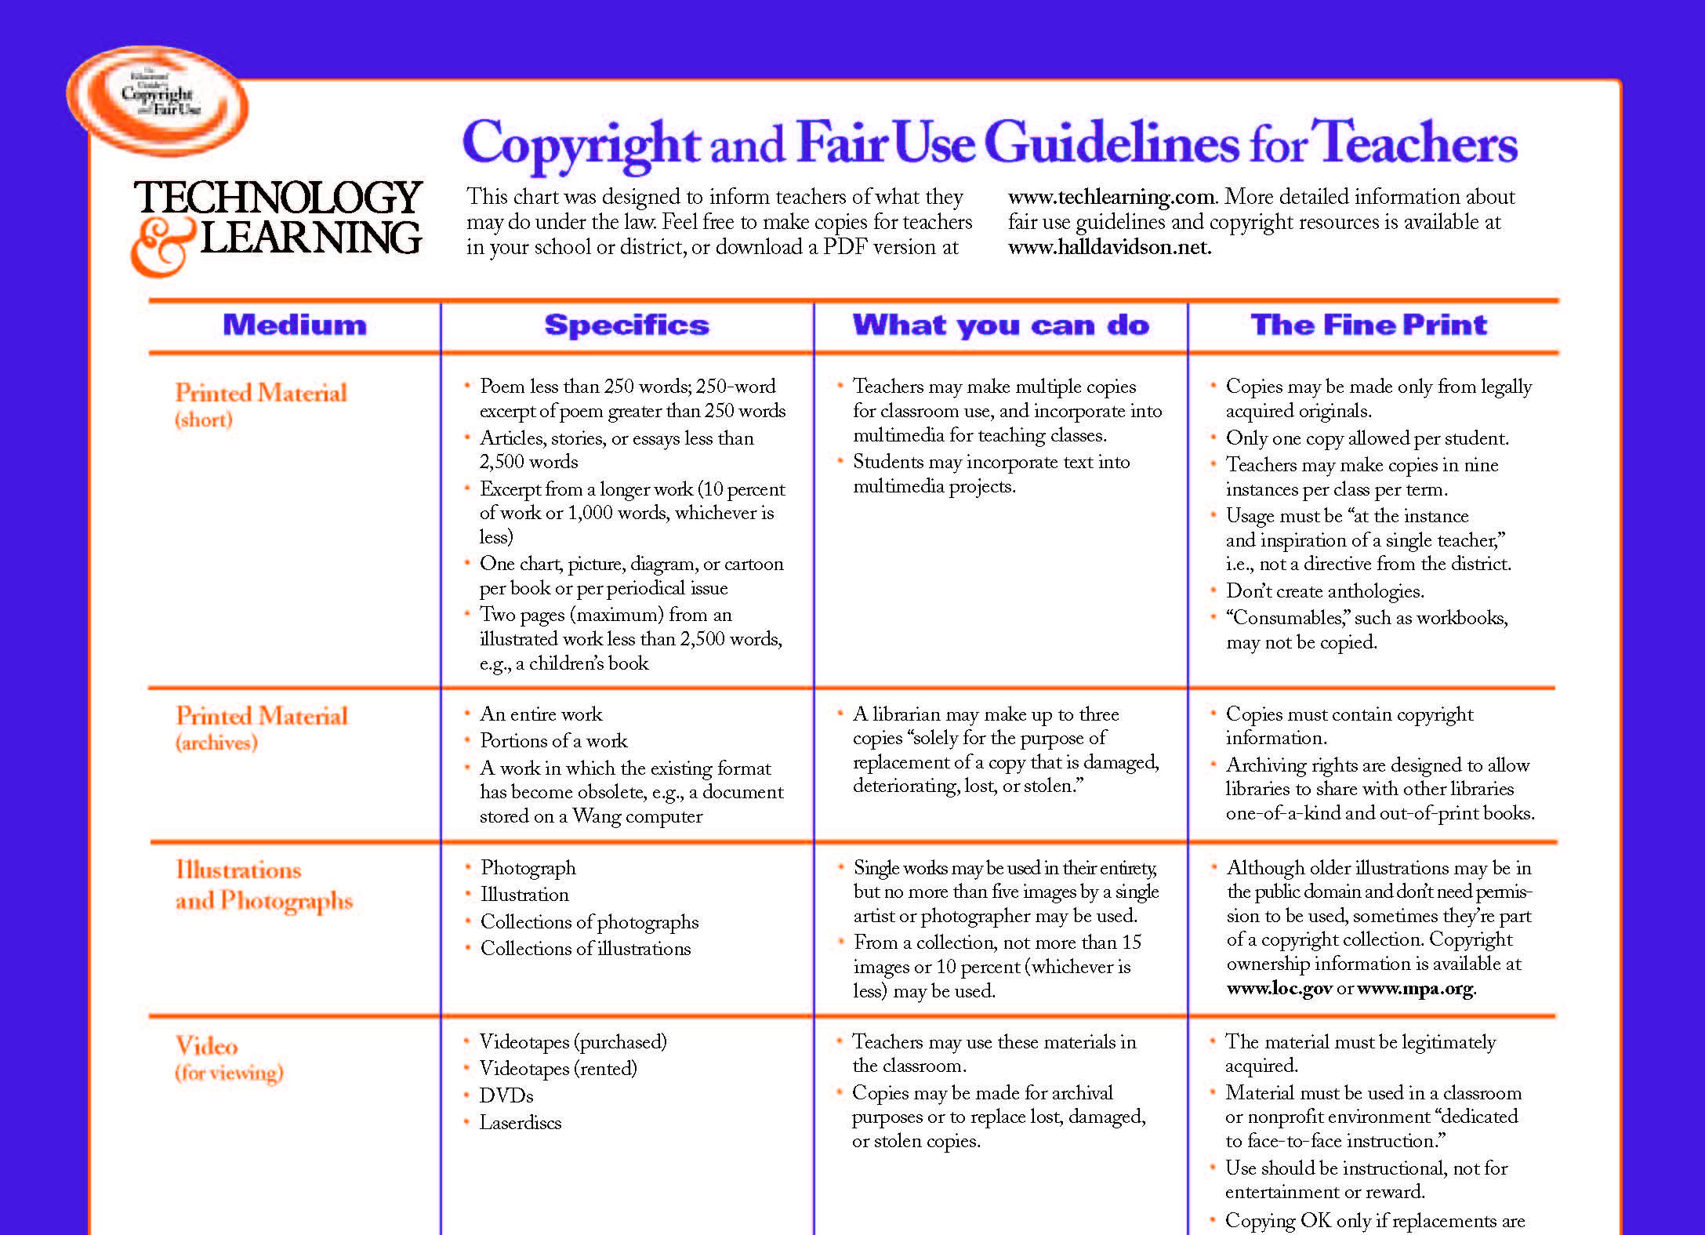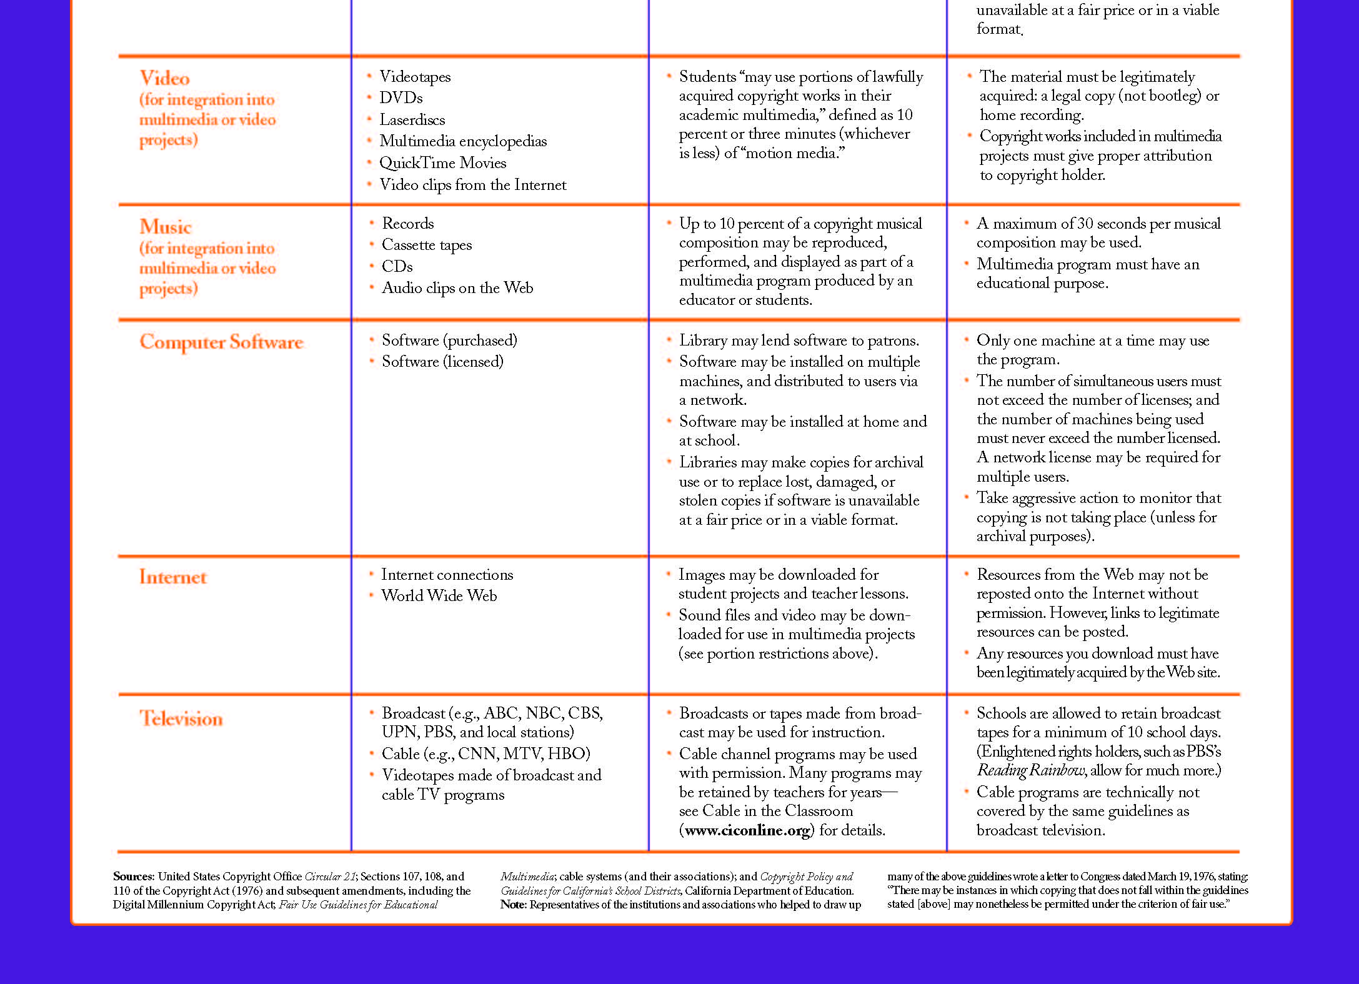

**INTERNET SAFETY FORMS**

The Internet permission forms are necessary for us to allow student work to be published on the web. These forms are located on the TOT website under the Internet Permission Forms folder. Direct links to the documents are provided below for your convenience.

English: <http://www.fresnounified.org/dept/it/ITI2/mstc/Internet%20Permission%20Forms/studentwebEnglish.pdf>

Spanish: <http://www.fresnounified.org/dept/it/ITI2/mstc/Internet%20Permission%20Forms/studentwebSpanish.pdf>

Hmong: <http://www.fresnounified.org/dept/it/ITI2/mstc/Internet%20Permission%20Forms/studentwebHmong.pdf>

Khmer: <http://www.fresnounified.org/dept/it/ITI2/mstc/Internet%20Permission%20Forms/studentwebKhmer.pdf>

Lao: <http://www.fresnounified.org/dept/it/ITI2/mstc/Internet%20Permission%20Forms/studentwebLao.pdf>

**SAMPLE PARENT LETTER**

11/17/2014

Dear Parent or Guardian,

I am pleased to inform you that your child has been selected to compete as a member of the 2015 Technology Team for ___________ School. The tournament events provide students with new opportunities to excel in school by developing technology literacy and problem solving skills.

As a member of the team, your child will be participating in one or two of the events below at the Eighth Annual, Fresno Unified School District, Tournament of Technology to be held Saturday, March 21st, 2015 at the brand new Gaston Middle School.

Teams are preparing for competition day in a number of ways, including making projects such as videos and LEGO robotic vehicles, infographics and 3D printed cars to name a few; and by practicing with technology tools including programming and multimedia applications for competitions that day. This year students will also compete in a live challenge that will require teams to engage in quick, creative, and critical thinking. At stake, are awards in each event and an overall school championship trophy.

You are invited to come watch the robotics competitions, car races and bridge testing during the morning as well as to attend the awards ceremony that afternoon.

Thank you for your support.

|  |  |
| --- | --- |
| **Event** | **Session /Time** |
| Video - PSA |  |
| Video - Advertisement |  |
| Video – Newscast |  |
| Video - Blockbuster |  |
| Science Infographic |  |
| Robotics – Robo Rally |  |
| Robotics - Line Follower |  |
| Robotics – Block Bots |  |
| Robotics – Battle Bots |  |
| Kodu Game Design |  |
| 3D Derby Races |  |
| 3D Bridge Design |  |

**CONTACT INFORMATION**

The Tournament of Technology is a coordinated effort between the Secondary Division, Information Technology, and Instructional Technology & Innovation.

**Tournament Coordinators**

Jeremy Ward

Computech Middle School

Phone: 559 457-2640  
[Jeremy.ward@fresnounified.org](mailto:Jeremy.ward@fresnounified.org)

Chris Fuge  
Sequoia Middle School  
Phone: 559 457-3210  
[chris.fuge@fresnounified.org](mailto:chris.fuge@fresnounified.org)

**Event Coordinators  
*Robotic Events:***  
 Philip Siechert  
 Kings Canyon Middle School  
 [philip.siechert@fresnounified.org](mailto:philip.siechert@fresnounified.org)

***Video Events:***  
 Jackie Burger

TSA

[jackie.burger@fresnounified.org](mailto:jackie.burger@fresnounified.org)

Ryan Coe  
 TSA  
 [ryan.coe@fresnounified.org](mailto:ryan.coe@fresnounified.org)

***Design Events:***  
 Floridia Cheung  
 Kings Canyon Middle School  
 [floridia.cheung@fresnounified.org](mailto:floridia.cheung@fresnounified.org)

Anthony Sombat  
 Gaston Middle School  
 [Anthony.sombat@fresnounified.org](mailto:Anthony.sombat@fresnounified.org)

**Tournament Coordinator Assistant**

Brian Dvorak

Instructional Technology & Innovation

1833 E Street, Fresno, CA 93706

Phone: 559 457-3919  
[brian.dvorak@fresnounified.org](mailto:brian.dvorak@fresnounified.org)

**Tournament Website:**  
Visit the [Tournament of Technology Website](https://www.fresnou.org/sites/tot/project/_layouts/15/start.aspx#/) or **go/TOT** to download individual Event Descriptions, see sample Design Documents and view Video Tutorials to help prepare and practice. You can also register as a coach to stay up to date on trainings and information.