Part 5: Adding a hole for the Axel
27) First you need to find the center of the wheel opening. Do this by using the line tool and placing it along the line of the wheel till it says MIDPOINT and turns BLUE. Then draw a line 3.0mm up. 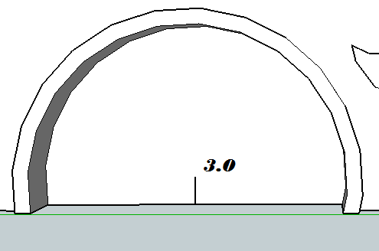
It is very important that the axel hole is placed directly in the center. Try different angles if it does not work the first time.

28) Now you can create a hole with the circle tool from the end of the line. Make the hole size a radius of 1.5mm
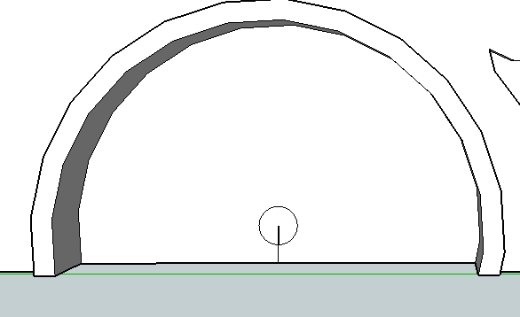
29) Then erase the lines so all that is left is the circle.
30) Then push the circle all the way through the car & use the Orbit Tool to see the other side

31) Sometimes the opening goes all the way through the car and out the other side. Use the orbit tool to check the other side of the car and make sure it went through.
32) If it went too far, just push it back in till it says “On Face”. Then let go and it will disappear.
33) You should now have a hole the size of the axel/nail you will be using to attach the wheels.
34) Repeat on the other wheel opening as well.

