**Part 6: Making the Wheels**  
  
35) First use the tape measure tool to find the diameter of your wheel well opening. Measure from endpoint to endpoint through the axel hole in the center. Then make a wheel that is **2mm smaller** than the opening.

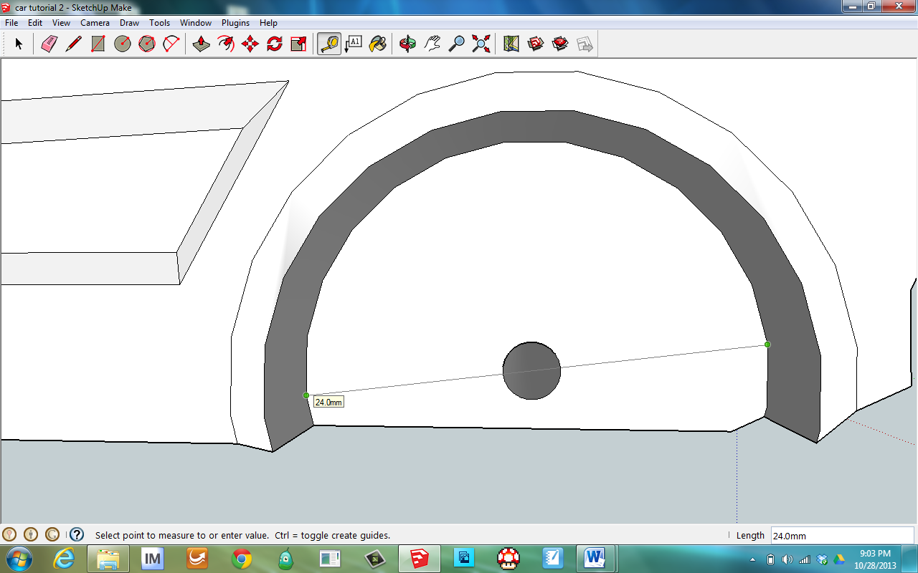



36) When you first select the Circle tool type in a number **between 100 and 200 and hit enter**, that way your wheel is nice and round. Remember, the circle tool shows the radius, which is half the diameter. **So if you want a 22mm wheel, draw a circle with an 11mm radius**.

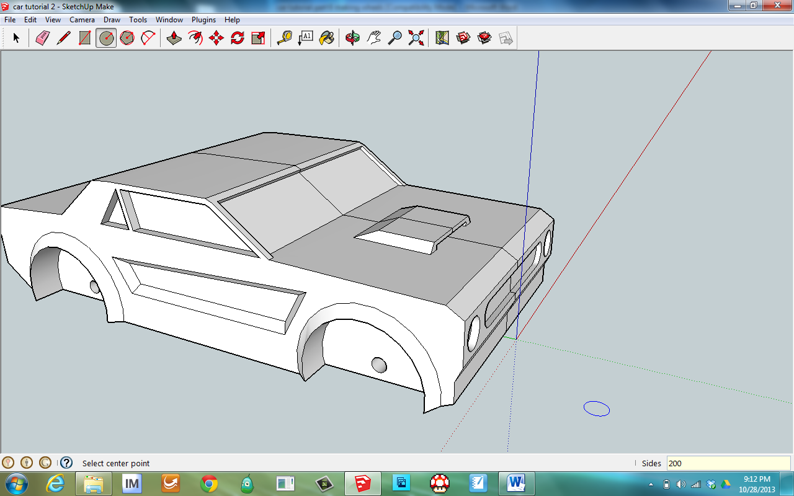 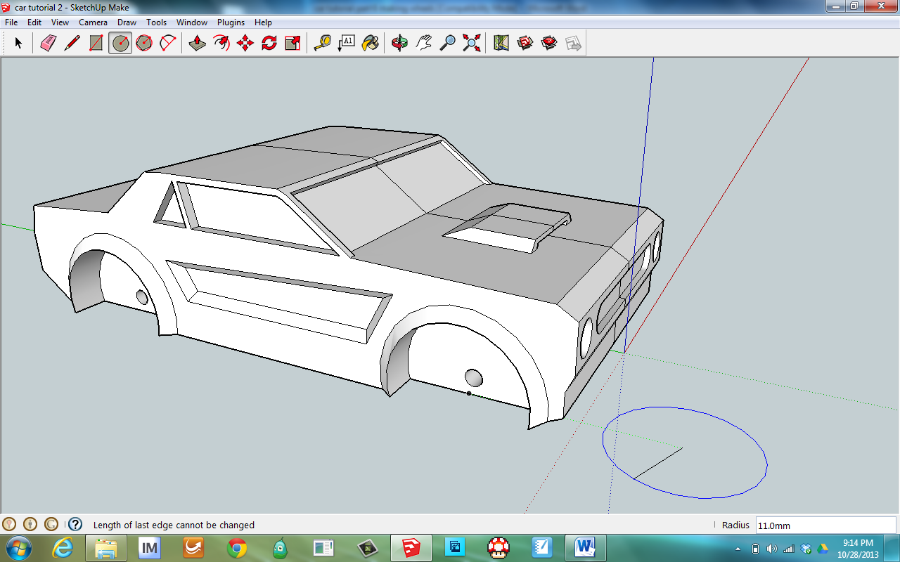

37) Then use the tape measure to find the depth of the wheel opening.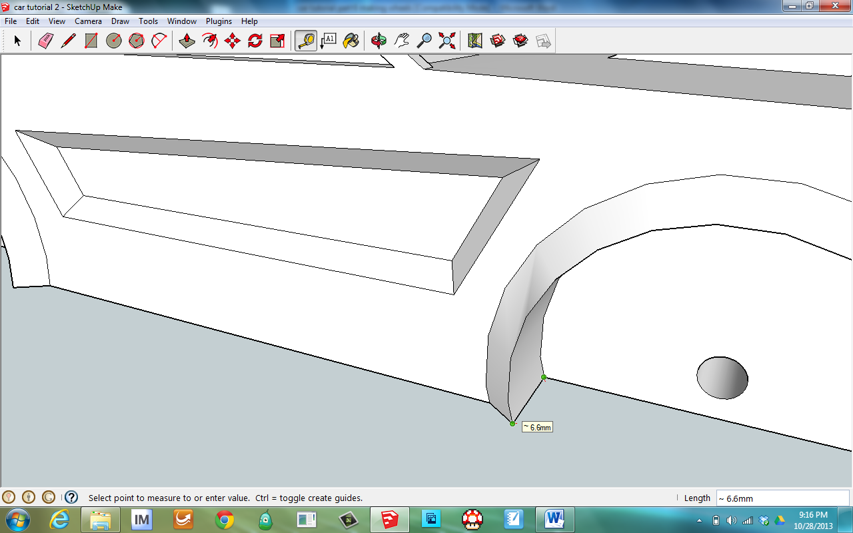

38) Use the push/pull tool to raise the wheel up to the depth of the wheel opening from the last step.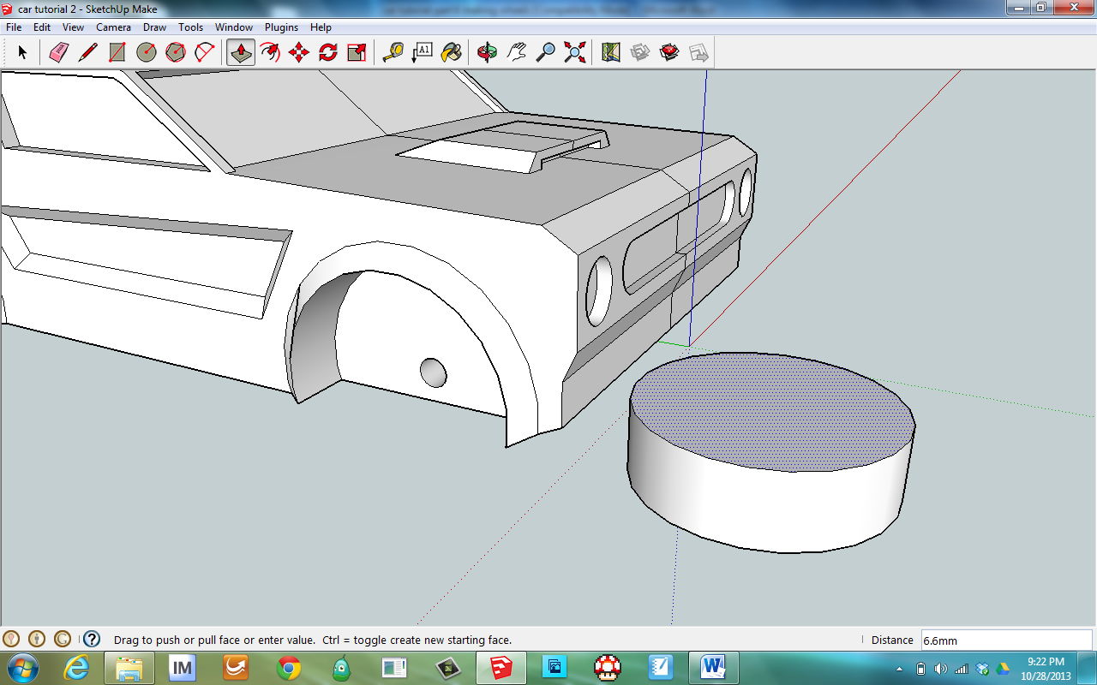

39) Add some detail to the wheel, try to design it so it prints with a flat side down. Use the offset tool   
to make the tire, then again to make a center hub to the wheel.

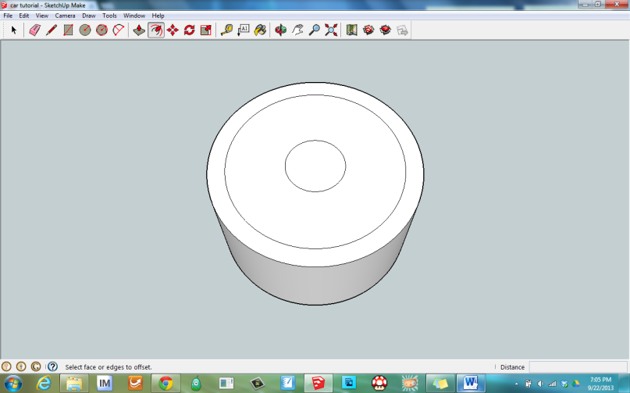

40) Then use the push/pull tool to add some dimension to the wheel.  
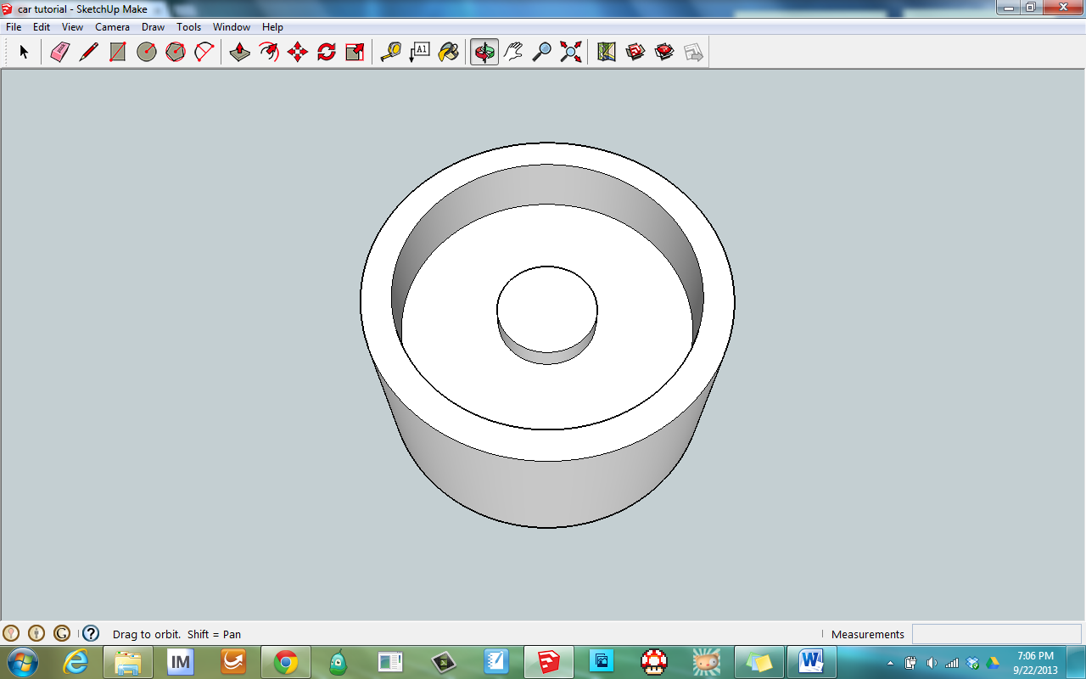

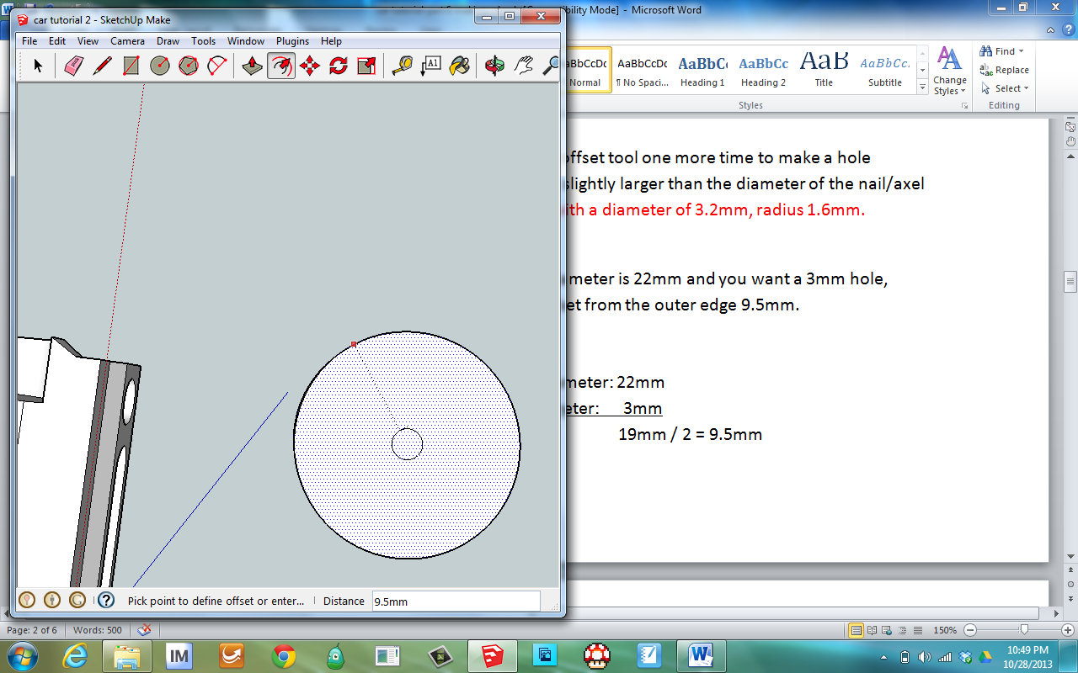41) Orbit to see the bottom side of the wheel. Use the offset tool one more time to make a hole through the wheel. The size of the hole needs to be just slightly larger than the diameter of the nail/axel you will use to attach the wheel to the car. (I did a hole with a diameter of 3.2mm, radius 1.6mm.)

If your wheel diameter is 22mm and you want a 3mm hole,   
you need to offset from the outer edge 9.5mm.  
  
Math:  
 Wheel Diameter: 22mm  
 - Hole diameter: 3mm  
 19mm / 2 = 9.5mm



42) Then use the push/pull tool to make an opening all the way through the wheel.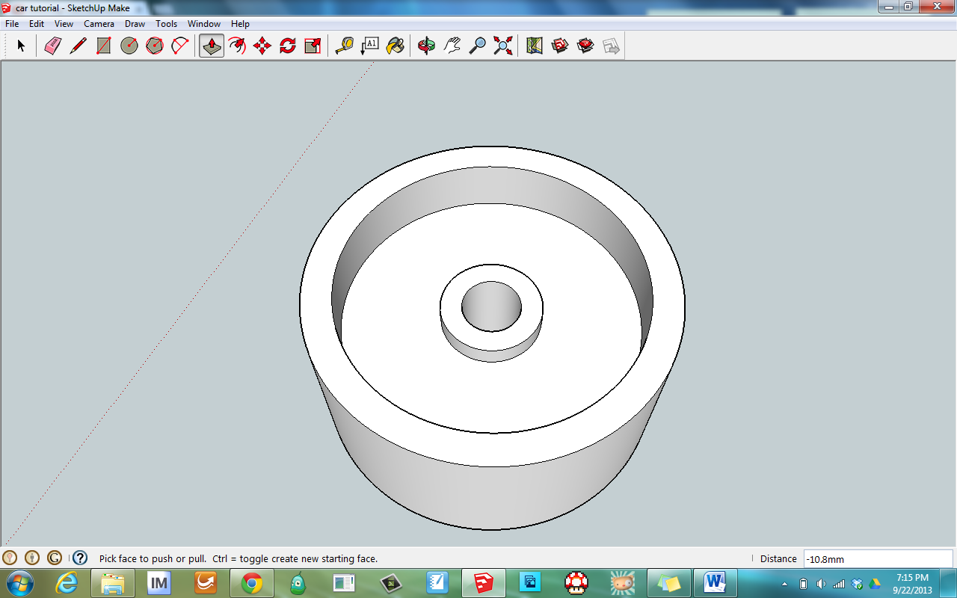

43) Sometimes the opening goes all the way through the wheel and out the other side. Use the orbit tool to make sure it went through. If it went too far, just push it back down to the face of the wheel.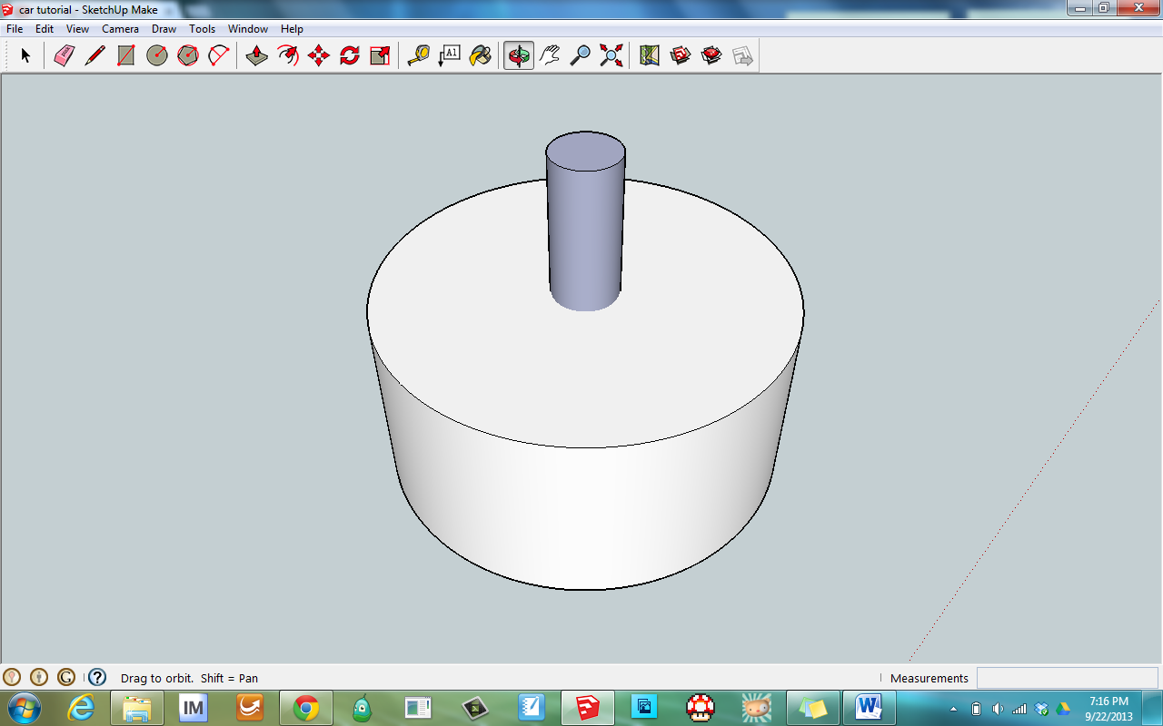

44) Then select the whole wheel by drawing a box around it. 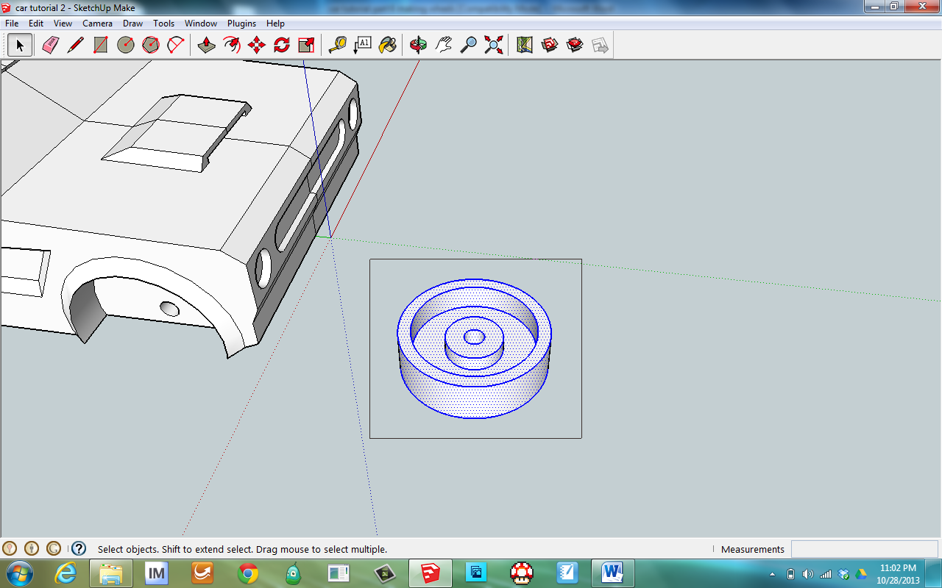

45) Then you can copy [ctrl-C] and paste [ctrl-V] the wheel to make 4 wheels for your car.  
Make sure all the bases of the wheels are at the same level as your car.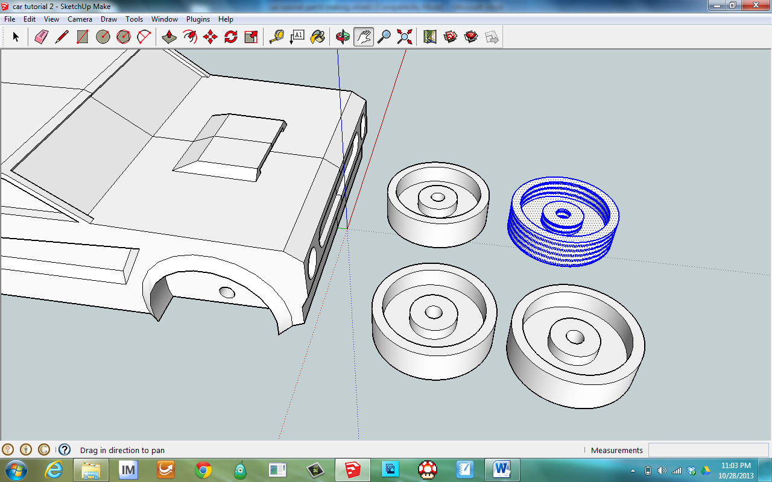 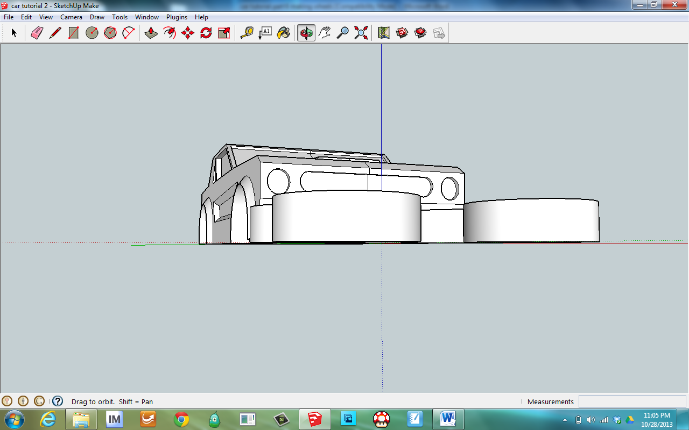

**46) Your car and wheels are now ready to print. You may want to save just the wheels as a separate file as you may need to adjust them slightly to fit your car and axel. You may also want to print them a different color.**