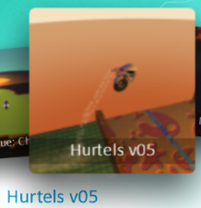  Object of the game:  Concentrate on jumping. Try not to hit the walls!  Controls:  A or Space Bar to jump |  | Evaluation: Tell me 1 Positive & 1 Negative thing about this game. Explain.  Overall Rating: 1 2 3 4 5
Object of the game:  Find and destroy the factory. Balloons are enemies.  Controls:  Use Arrow Keys to move  Left click Mouse to shoot  Space Bar to Jump |  | Evaluation: Tell me 1 Positive & 1 Negative thing about this game. Explain.  Overall Rating: 1 2 3 4 5
Object of the game:  Stay on the lava until you explode!!! If you fall off, try again.  Controls:  Use Arrow keys to move |  | Evaluation: Tell me 1 Positive & 1 Negative thing about this game. Explain.  Overall Rating: 1 2 3 4 5
Object of the game:  Destroy all saucers and avoid getting hit!  Controls:  Use Arrow keys to move  Space Bar to Shoot  S button for Shield | Evaluation: Tell me 1 Positive & 1 Negative thing about this game. Explain.  Overall Rating: 1 2 3 4 5
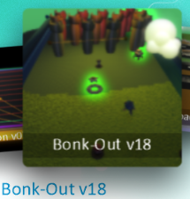  Object of the game:  Protect the red turrets. Catch saucers for bonuses.  Controls:  Press A to launch a ball | Evaluation: Tell me 1 Positive & 1 Negative thing about this game. Explain.  Overall Rating: 1 2 3 4 5
Object of the game:  Weave & survive your way through the traffic.  Controls:  Use the Arrow keys to navigate. | Evaluation: Tell me 1 Positive & 1 Negative thing about this game. Explain.  Overall Rating: 1 2 3 4 5

