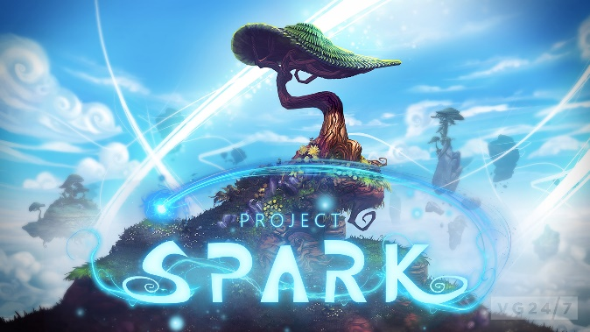
Name: _______________
Period: _______________

7 Essential Questions:

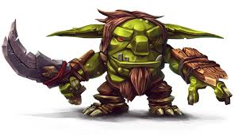
- What type of game did you make? (circle one)
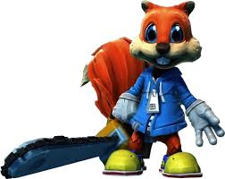
Exploring/Story Racing
The characters are free to move around The characters must follow a
on their own and must complete a task specific path in a certain time

- Who is the main character & what actions did you program them to do?
Examples: Soldier, warrior, & do they Shoot, jump, etc.
___________________________________________________________________________________________________________________________________

- Every game has a strong story. What is your storyline? Expalin!
Examples: You are a renegade samurai who is seeking revenge for his village against the evil group of warriors.
____________________________________________________________________________________________________________________________________

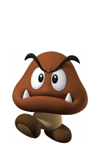
- What is the objective?
What should your characters do? What is their goal in the game?
Examples: Collect coins, kill enemies, complete a race . . .
____________________________________________________________________________________________________________________________________

- What are the challenges?
What will make the game difficult and entertaining?
Examples: Bad guys, obstacles, time limit . . . ____________________________________________________________________________________________________________________________________
- Explain why this game would be fun for others to play?
Examples: Graphics, characters, hidden secrets, gameplay.
____________________________________________________________________________________________________________________________________

- What are 2 things you liked & 2 things you didn’t like about this project?
Examples: Graphics, characters, hidden secrets, gameplay.
____________________________________________________________________________________________________________________________________________________________________________________________________________________________

