SketchUp Cheat Sheet
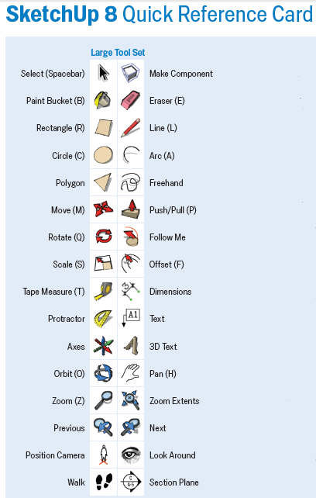

Important: To get straight angles and views use “Camera Angles.”
- Click on the CAMERA tab at the top of the screen.
- Click on STANDARD VIEWS.
- Select your view.
